“Introduction To Next Generation Reservoir Computing ”

Semester Project Report

* EP20BTECH11019 (Rahhul J)

Overview:

In this report we will discuss about the things that were done in the project during the course of this semester. We would begin with the thesis review of –

“Compensation Through Prediction For Atmospheric Turbulence Effect On Target Imaging And High Energy Laser Beam”by Jun H. Zhang and the paper review of

“Adaptive Optics Based On Machine Learning: a Review”by Guo YM, Zhong LB, Min L, Wang JY, Wu Y et al. Then we would look at an introduction to Reservoir Computing and the development of the Next Generation of Reservoir Computing(NG-RC). In a sense, our objective of the project is to try implementing the NG-RC in place of CNN, that has been used in the paper, in order to reduce the requirement of training data and reduce the training times. In addition to this we would look at some simulation done during the course of the project.

1)Thesis Review:

High Energy Laser (HEL) systems have immense potential in military applications due to its unlimited rounds, precision strike and speed of attack. HEL systems had been extensively evaluated and can potentially be effectively against traditional threats like missile strikes and adversarial ships. However, HEL systems do not come without limitations. The presence of air molecules, water vapor and salt particles in the maritime environment significantly alters the beam focus and reduces the effective range of a laser. In addition, atmospheric turbulence can also be caused by variations in the index of refraction in the atmosphere, causing further degradation of the laser beam during its propagation through the atmosphere. To increase its effectiveness, atmospheric turbulence effects need to be compensated in the laser beam. Adaptive Optics (AO) systems with wavefront sensors and Deformable Mirrors (DM) are required to correct the atmospheric turbulence before the beam propagates through the atmosphere to reduce the effects of turbulence.

The concepts of optics and adaptive optics are required to better explain the study. Figure 2 shows a graphical representation of two cases with and without atmospheric turbulence in the atmosphere. The wavefront is represented as an imaginary surface representing points of a wave that vibrate in unison. When wavefronts of a point source pass through an ideal atmosphere with no turbulence, the resulting image observed at the telescope is a focused airy disk. However, with turbulence, the resulting telescope image is an aberrated image with distortion. The telescope images of these point sources are also referred to as PSF images.

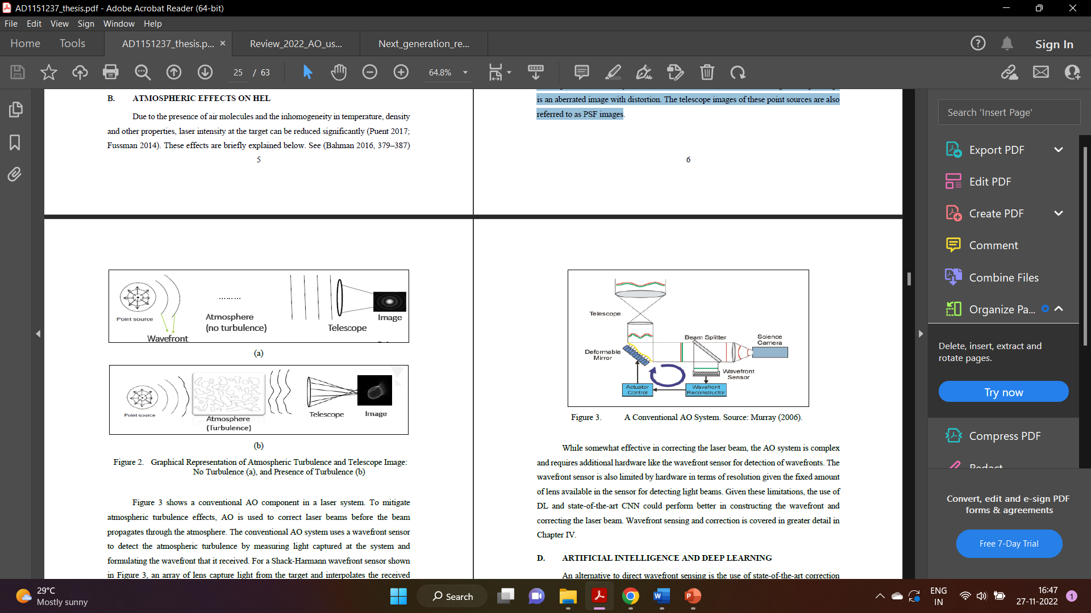

Figure 3 shows a conventional AO component in a laser system. To mitigate atmospheric turbulence effects, AO is used to correct laser beams before the beam propagates through the atmosphere. The conventional AO system uses a wavefront sensor to detect the atmospheric turbulence by measuring light captured at the system and formulating the wavefront that it received. For a Shack-Harmann wavefront sensor shown in Figure 3, an array of lens capture light from the target and interpolates the received wavefront. Coupled with a processing computer, the wavefront is re-constructed, the conjugate of the re-constructed wavefront is then fed to the DM to correct the laser beam before propagating it through the atmosphere to the target.

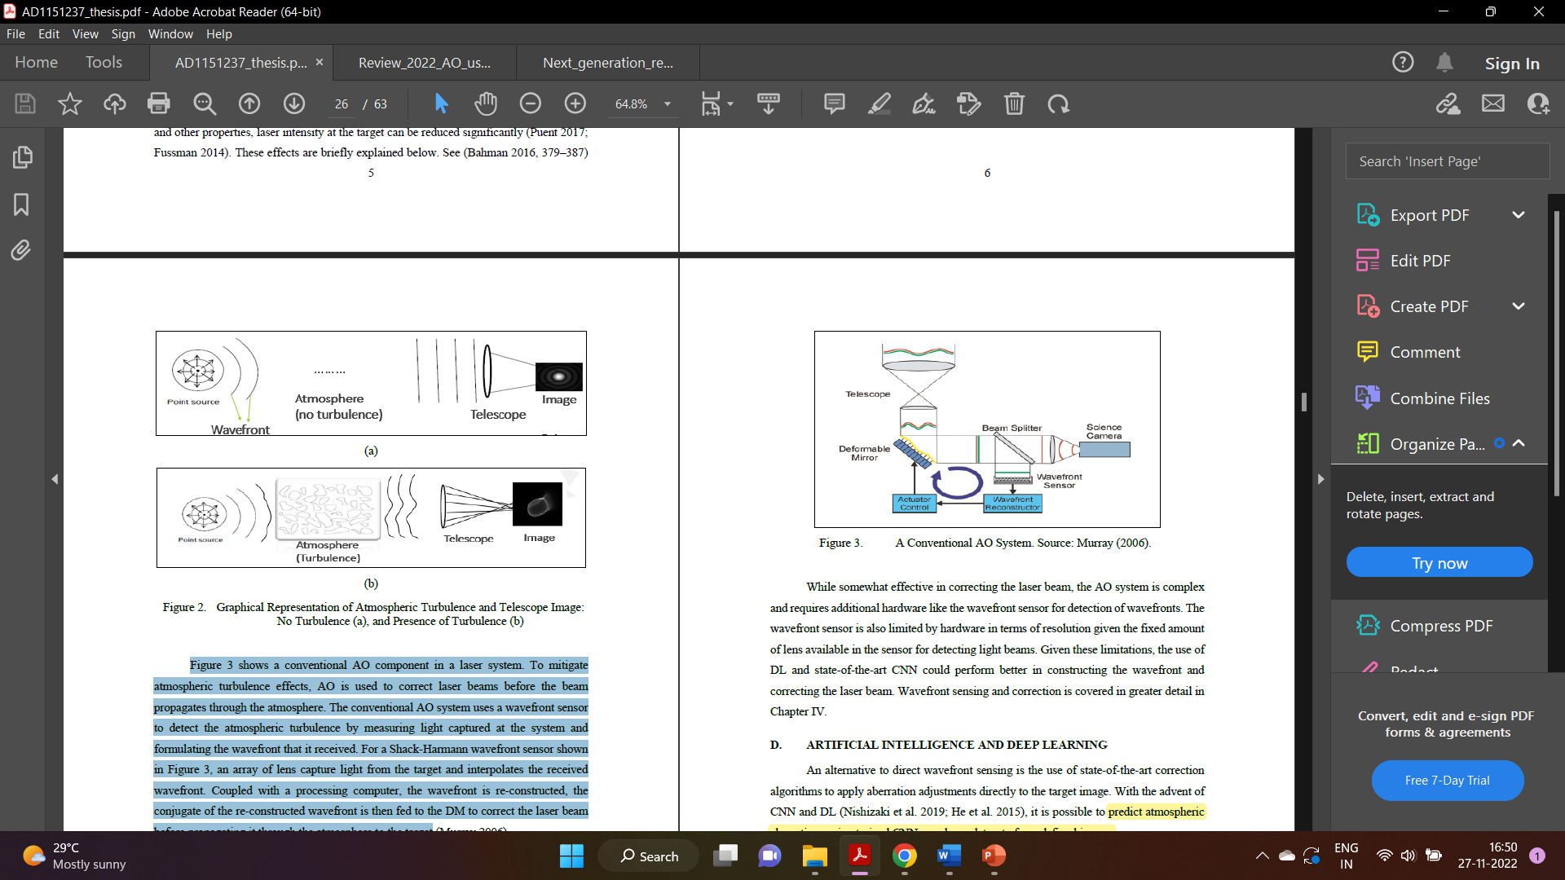

Current technologies for beam correction are limited by the wavefront sensor’s resolution and the increasing capital cost to improve correction via the number of correction elements in the wavefront sensor. However, with the advent of Artificial Intelligence (AI) and Deep Learning (DL) for image correction, an opportunity to improve image quality and beam effectiveness is available. This thesis investigates the use of AI tools like Convolutional Neural Networks (CNN) and DL in predicting atmospheric turbulence for laser beam correction to increase the effectiveness of a HEL system.

First, a simplified optical model is conceived and used as a testbed to evaluate prediction performance of atmospheric turbulence. In particular, a point light source on a target and the corresponding Point Spread Function (PSF) image is generated for training the network. Zernike polynomials are used to represent the wavefront error of the light caused by the atmospheric turbulence. Second, the trained network is applied to simulated real-life Unmanned Aerial Vehicle (UAV) images dataset for Mongoose and Reaper UAVs. Third, a model is proposed for direct image correction of blur image caused by atmospheric turbulence to clear pristine image to improve target tracking in the HEL system. The computer simulations conducted in this thesis were based on MATLAB’s DL toolbox and architecture.

An alternative to direct wavefront sensing is the use of state-of-the-art correction algorithms to apply aberration adjustments directly to the target image. With the advent of CNN and DL (Nishizaki et al. 2019; He et al. 2015), it is possible to predict atmospheric aberrations using trained CNN on a large dataset of pre-defined images. The training of CNNs is generally split into supervised and unsupervised training. In this study, all training done are supervised training to guarantee performance of the model. First, the CNN can be fed images with known atmospheric turbulence induced aberrations (modelled with 33 term Zernike polynomials) and a prediction can be derived by the trained CNN. Second, the CNN can be used to deduced blurred images given correct clear pristine images as reference training material.

The Residual Network (ResNet) was introduced by (He et al. 2015) for image classification using deeper neural networks. While the ResNet was substantially deeper than other neural networks proposed, it was easier to train and optimize because of its lower complexity. The main feature of the ResNet is a residual learning block which bypasses certain number of layers such that the original data is still retained. These short-cut connections do not add additional learnable parameters or contribute to the complexity of the computation, which makes the network trainable with lesser time and resources.

The U-Net is a CNN used for biomedical image segmentation. It consists of an encoder and decoder subnetwork that are connected by a bridge section which enables strong data augmentation in training the network. This network could be used to train from start to end using very few images and yet still outperforms other networks in image segmentation of electron microscopic stacks (Ronneberger, Fischer, and Brox 2015). The main features of the U-Net are the ability to obtain good training results even with little image dataset. The simplicity of the network also means that the network is sufficiently fast for close to real time applications in the context of target tracking or HEL beam propagation.

The most common method to represent atmospheric turbulence effects on a beam is through the use of Zernike polynomials. Expressed conveniently in polar coordinates *r* and θ. Figure 9 shows the Zernike polynomials and the respective shape of wavefront.

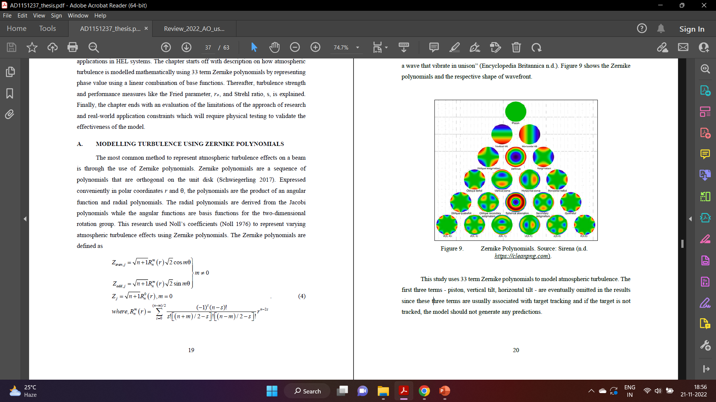 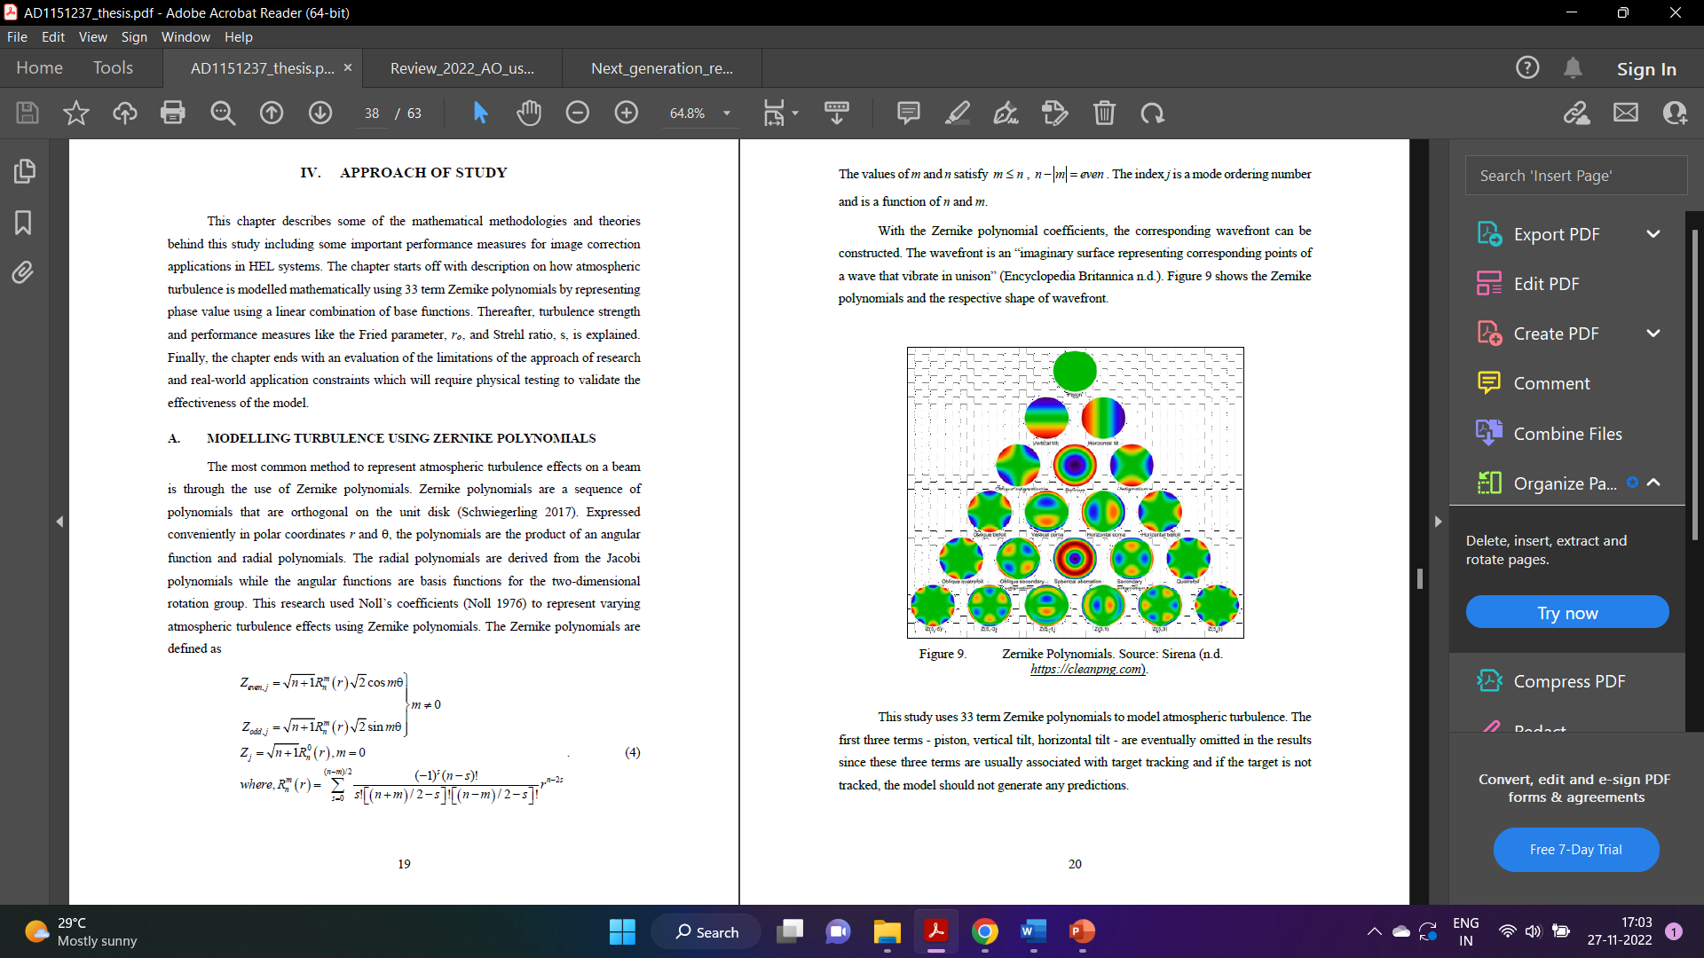

This study uses 33 term Zernike polynomials to model atmospheric turbulence. The first three terms - piston, vertical tilt, horizontal tilt - are eventually omitted in the results since these three terms are usually associated with target tracking and if the target is not tracked, the model should not generate any predictions.

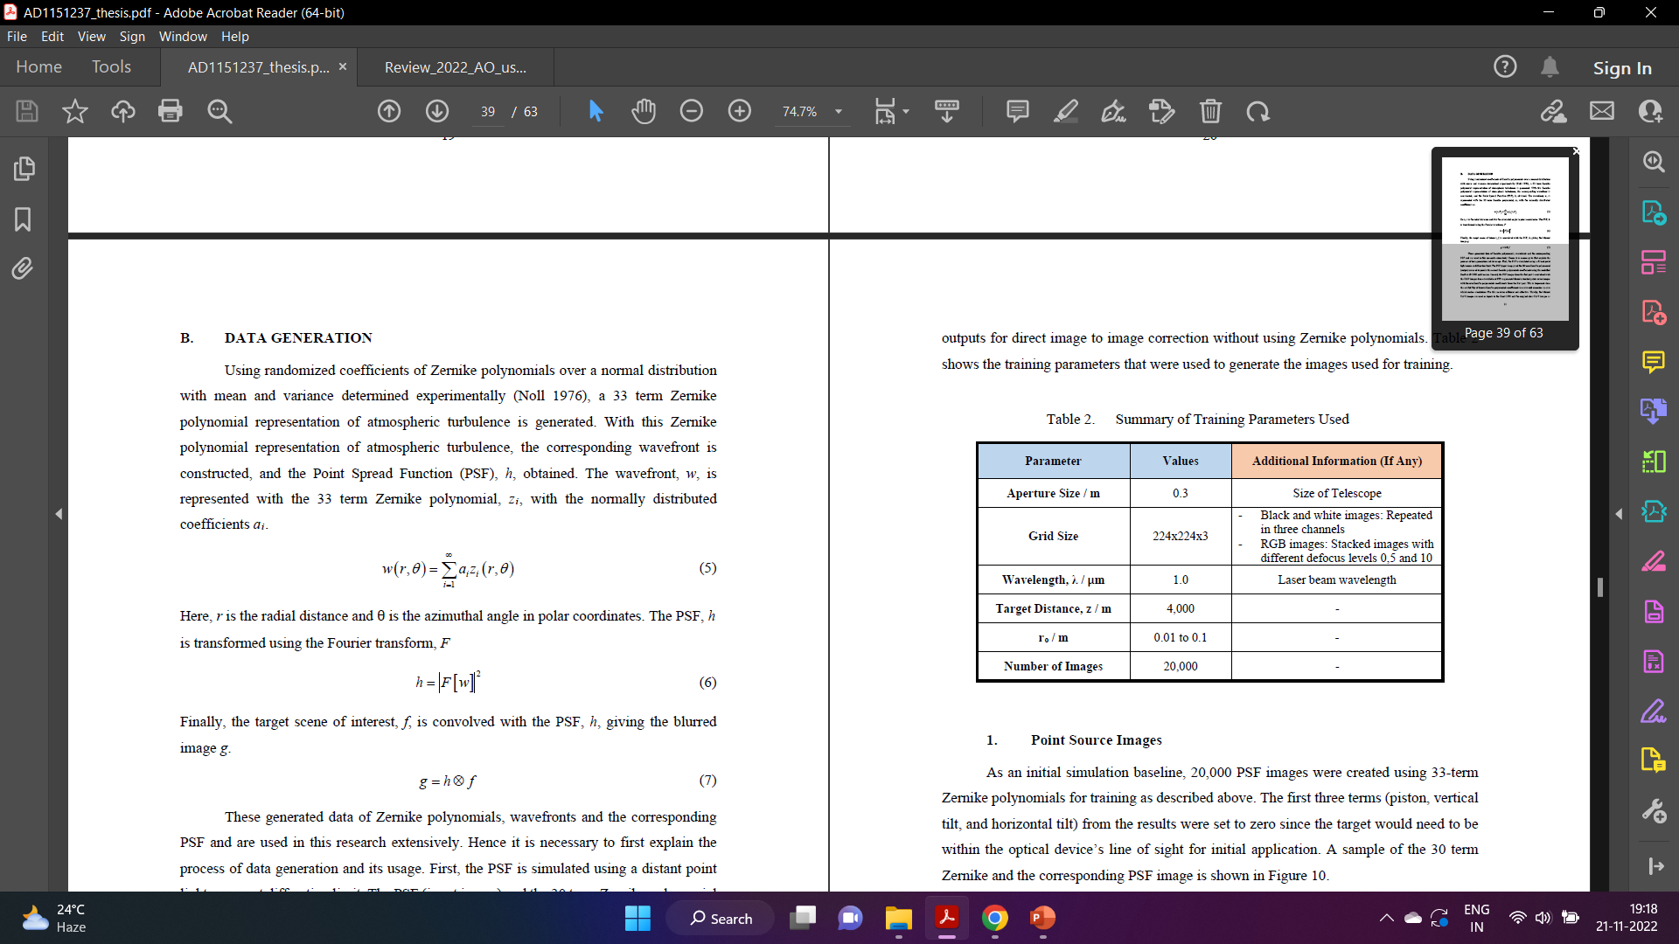

First, the PSF is simulated using a distant point light source at diffraction limit. The PSF (input image) and the 30 term Zernike polynomial (output) are used to predict the correct Zernike polynomials coefficients using the modified ResNet-18 CNN architecture. Second, the PSF images from the first part is convolved with the UAV images dataset available at NPS to generate blurred extended point source images with **known** Zernike polynomials coefficients from the first part. Thirdly, the blurred UAV images are used as inputs to the U-Net CNN and the original clear UAV images as outputs for direct image to image correction without using Zernike polynomials. Table 2 shows the training parameters that were used to generate the images used for training.

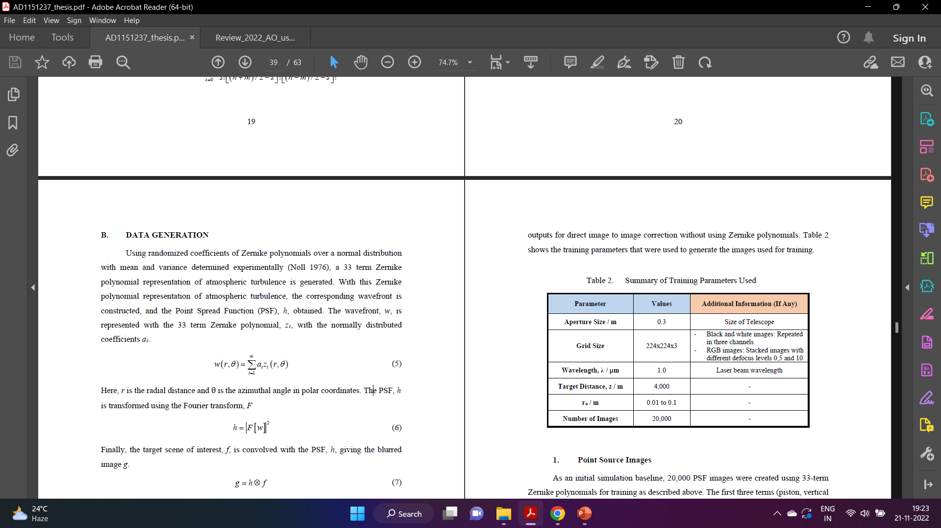

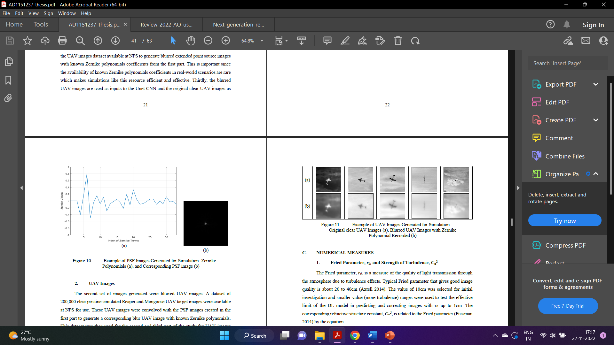 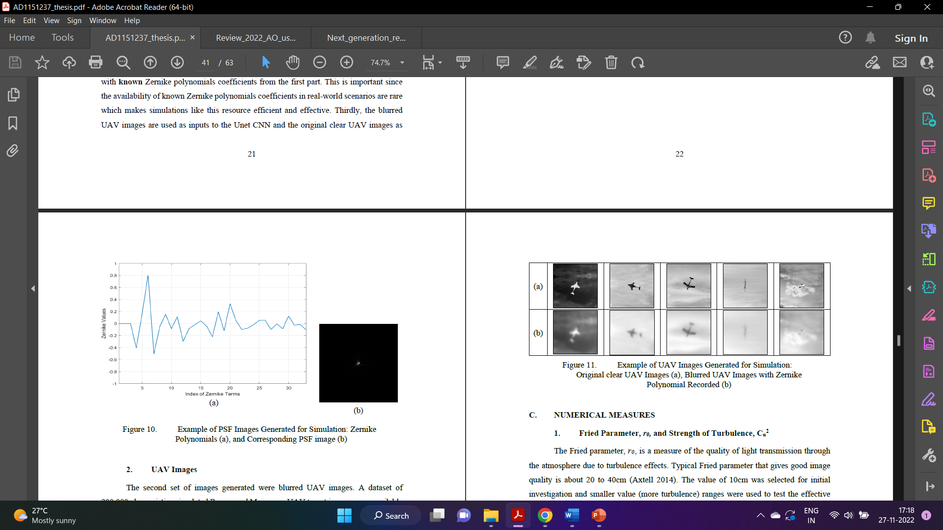

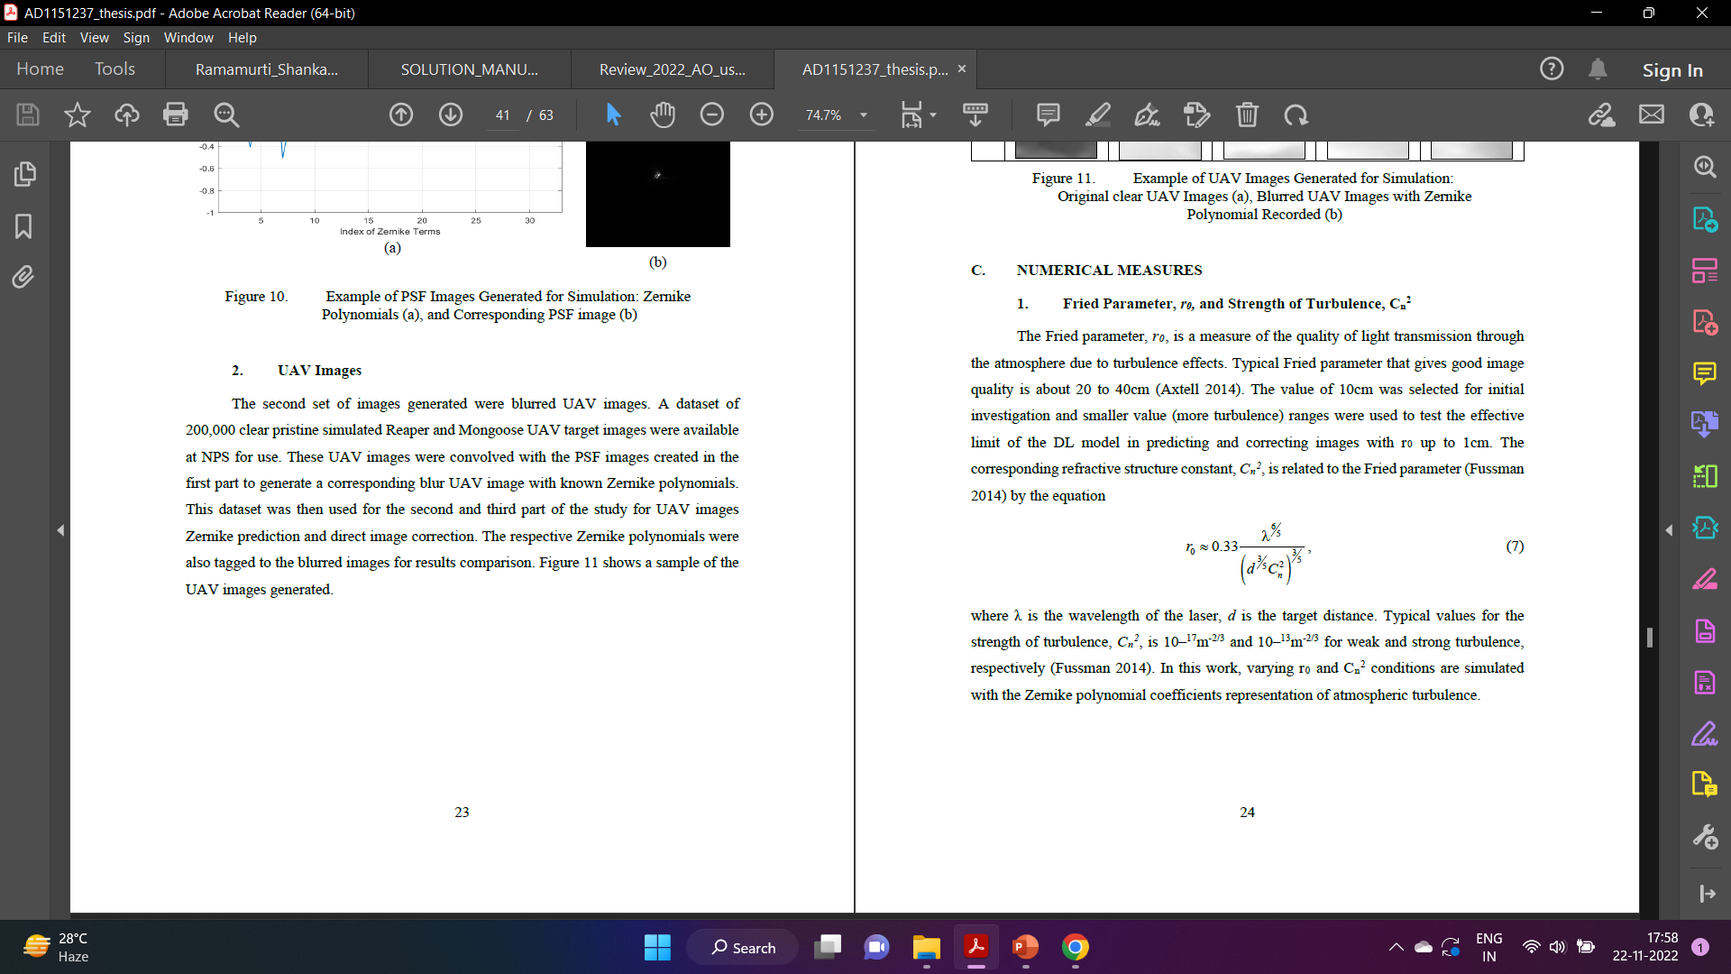

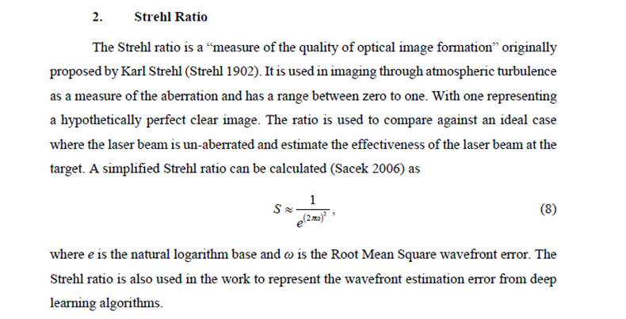

The PSF images generated were used to train the ResNet-18 CNN to output the expected 30 term Zernike polynomial. The prediction accuracy was found to be poor. Other than using a focused PSF image, defocus was also added to the PSF image to simulate phase diverse data for simulation. Figure 12 shows the PSF image from Figure 9 with an added defocus level of 5, 10 and 20 in the focus term of Zernike polynomials. Due to the nature of image recognition-related DL and the computer “seeing”these images, the prediction results obtained was best when defocus was added. This likely gave the network more information to predict and estimate the Zernike polynomials compared to the focused PSF image which has little information all concentrated in a few pixels in the middle of the image.

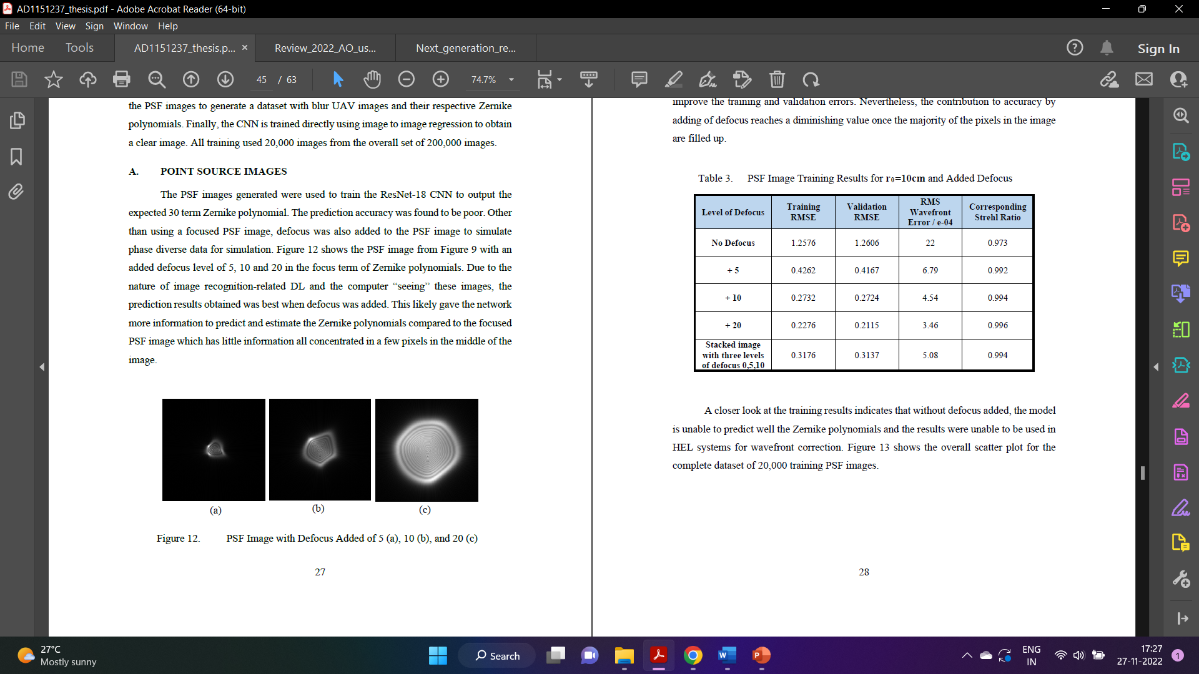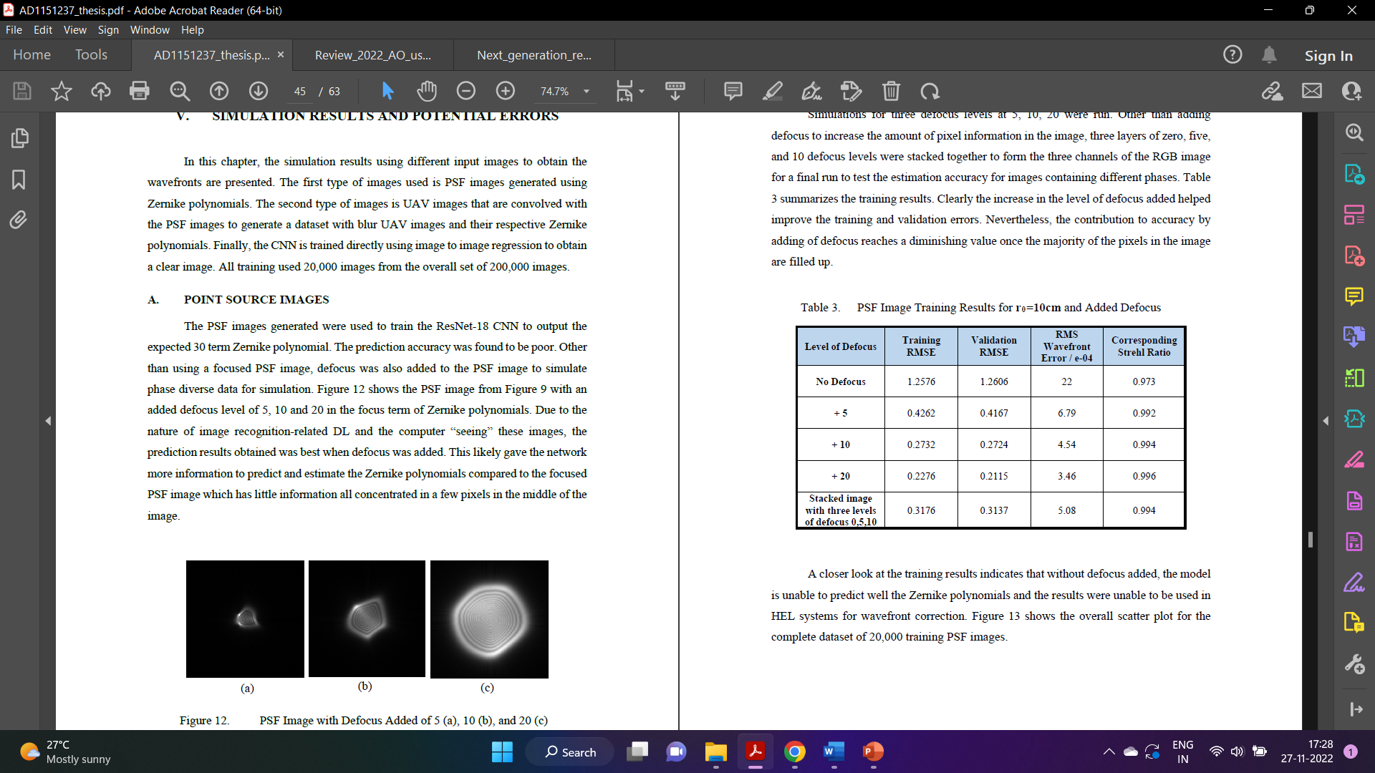

A closer look at the training results indicates that without defocus added, the model is unable to predict well the Zernike polynomials and the results were unable to be used in HEL systems for wavefront correction. Figure 13 shows the overall scatter plot for the complete dataset of 20,000 training PSF images.

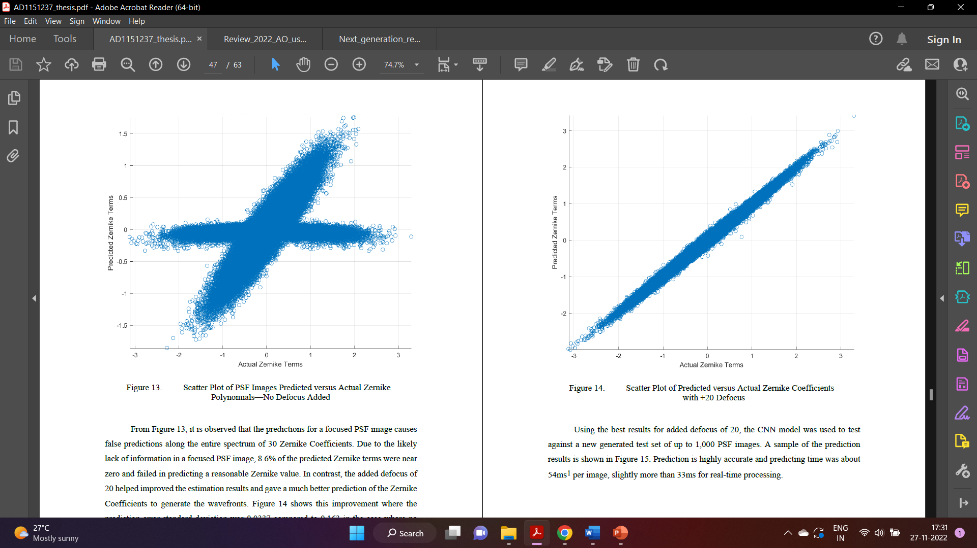

From Figure 13, it is observed that the predictions for a focused PSF image causes false predictions along the entire spectrum of 30 Zernike Coefficients. Due to the likely lack of information in a focused PSF image, 8.6% of the predicted Zernike terms were near zero and failed in predicting a reasonable Zernike value. In contrast, the added defocus of 20 helped improved the estimation results and gave a much better prediction of the Zernike Coefficients to generate the wavefronts. Figure 14 shows this improvement where the prediction error standard deviation was 0.0337 compared to 0.163 in the case where no defocus was added. Using the best results for added defocus of 20, the CNN model was used to test against a new generated test set of up to 1,000 PSF images. A sample of the prediction results is shown in Figure 15. Prediction is highly accurate and predicting time was about 54ms1 per image, slightly more than 33ms for real-time processing. Given the close approximation of the actual Zernike Coefficients in the predicted values, the predicted wavefront also closely resembles the actual wavefront as illustrated in Figure 16.

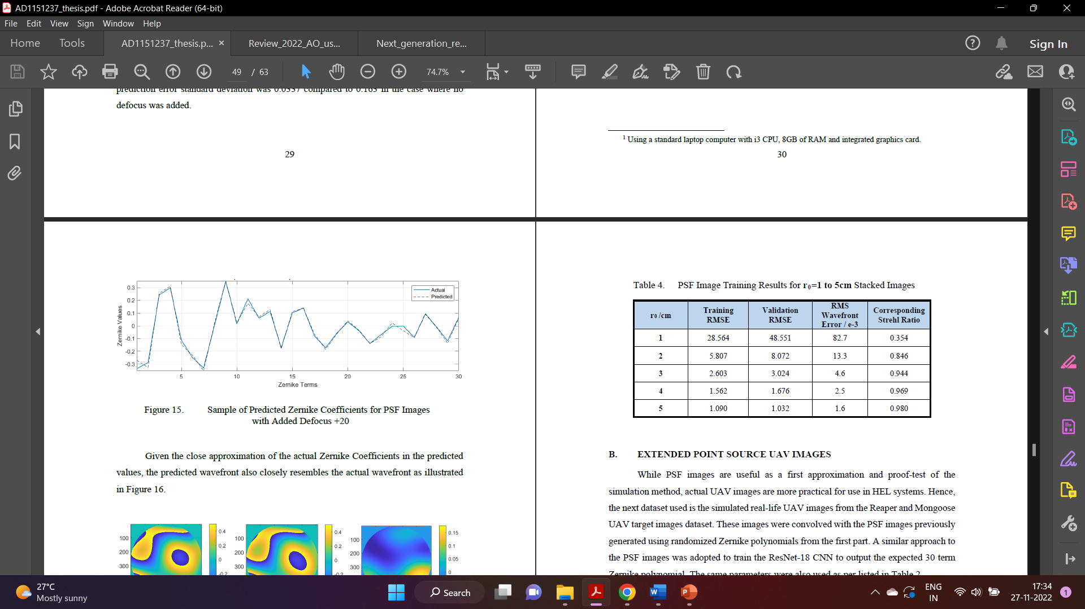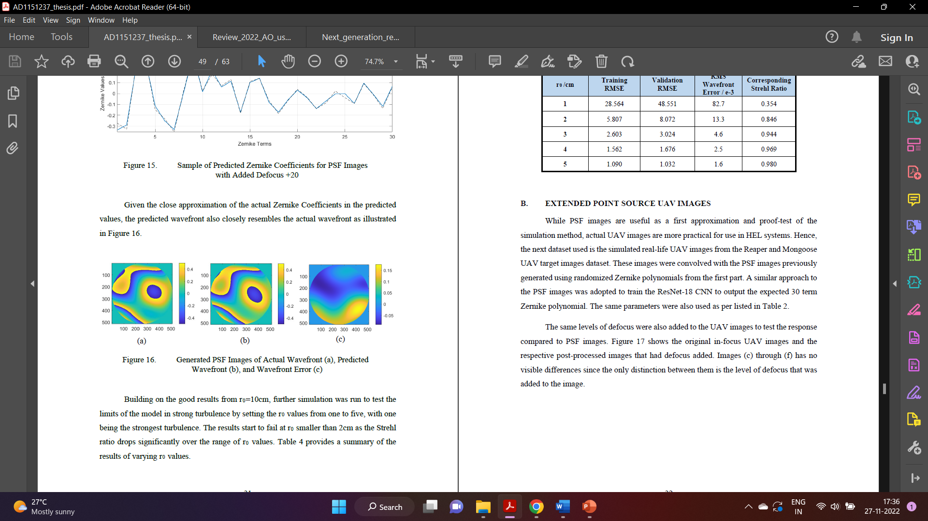

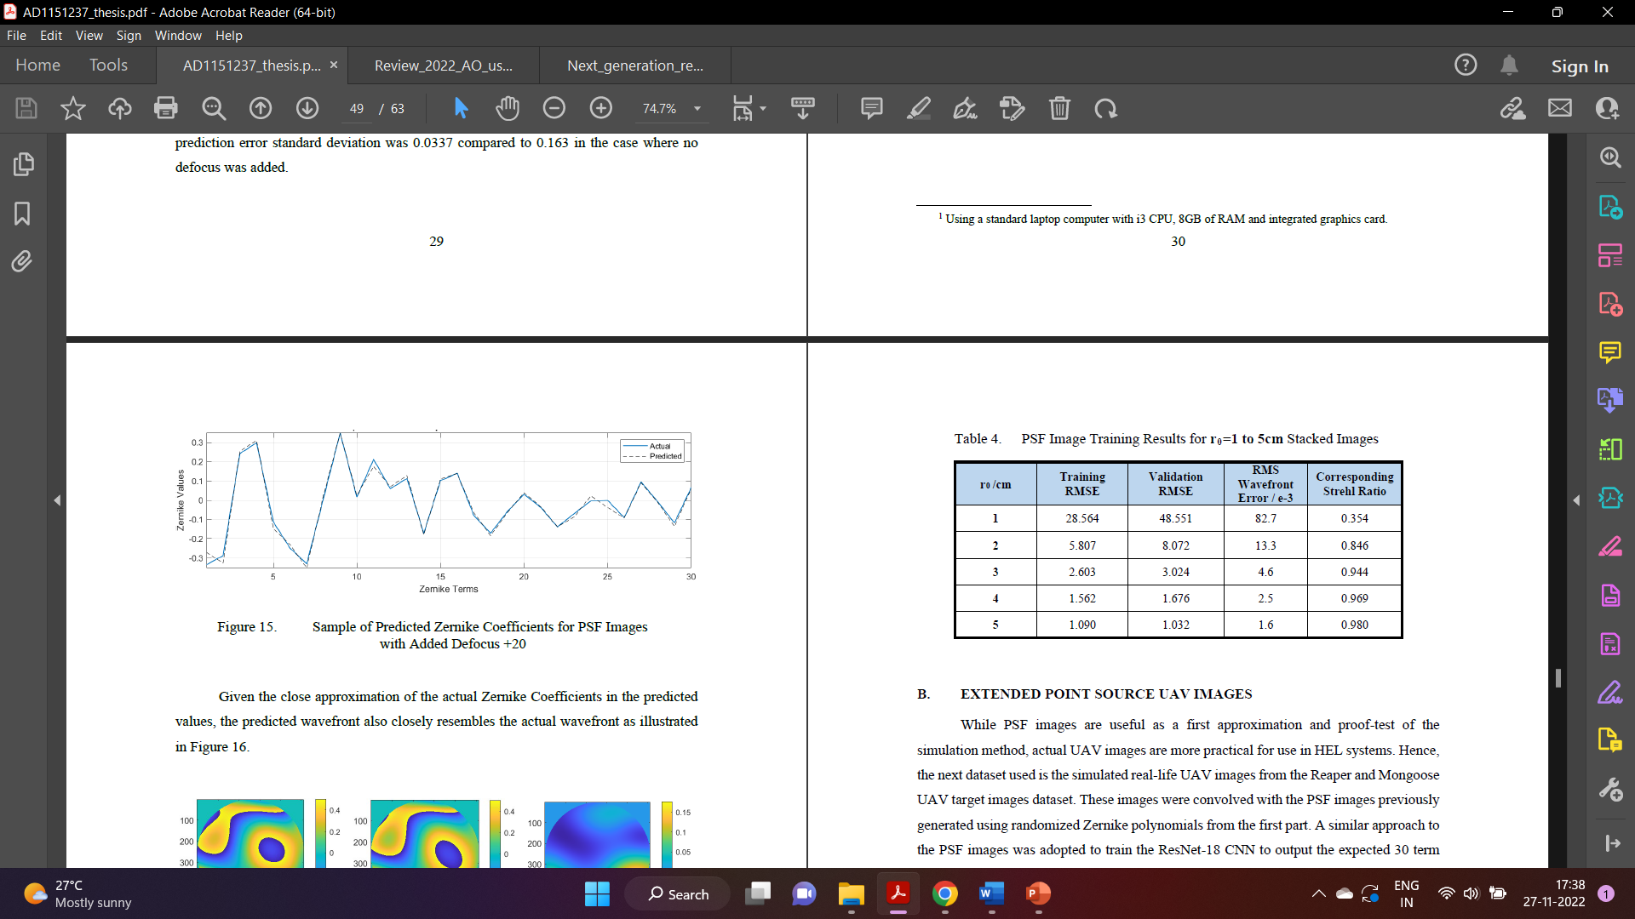

While PSF images are useful as a first approximation and proof-test of the simulation method, actual UAV images are more practical for use in HEL systems. Hence, the next dataset used is the simulated real-life UAV images from the Reaper and Mongoose UAV target images dataset. These images were convolved with the PSF images previously generated using randomized Zernike polynomials from the first part. A similar approach to the PSF images was adopted to train the ResNet-18 CNN to output the expected 30 term Zernike polynomial. The same parameters were also used as per listed in Table 2. The same levels of defocus were also added to the UAV images to test the response compared to PSF images. Figure 17 shows the original in-focus UAV images and the respective post-processed images that had defocus added. Images (c) through (f) has no visible differences since the only distinction between them is the level of defocus that was added to the image.

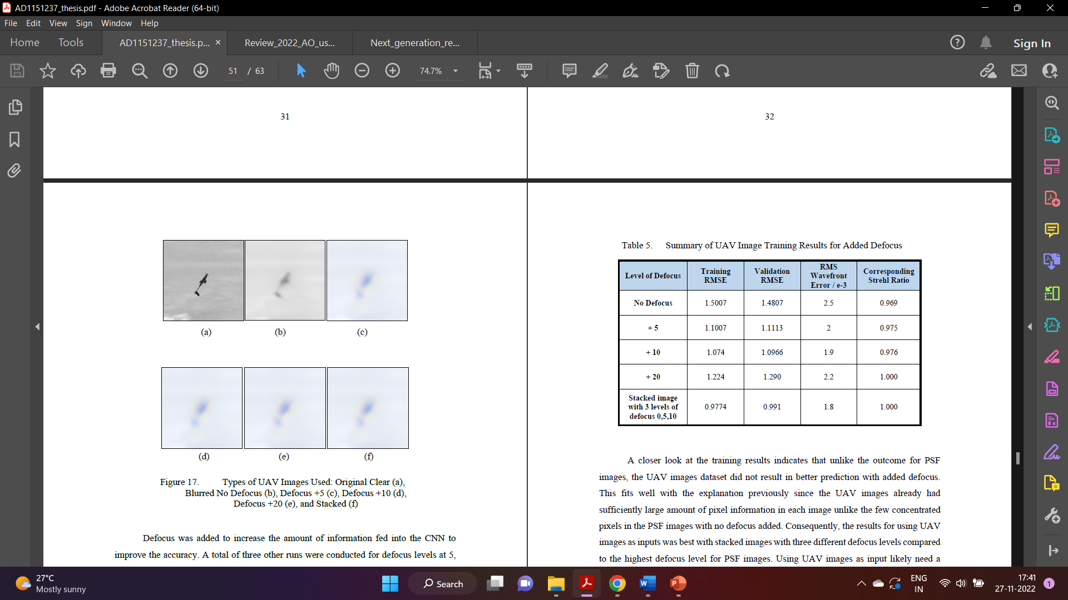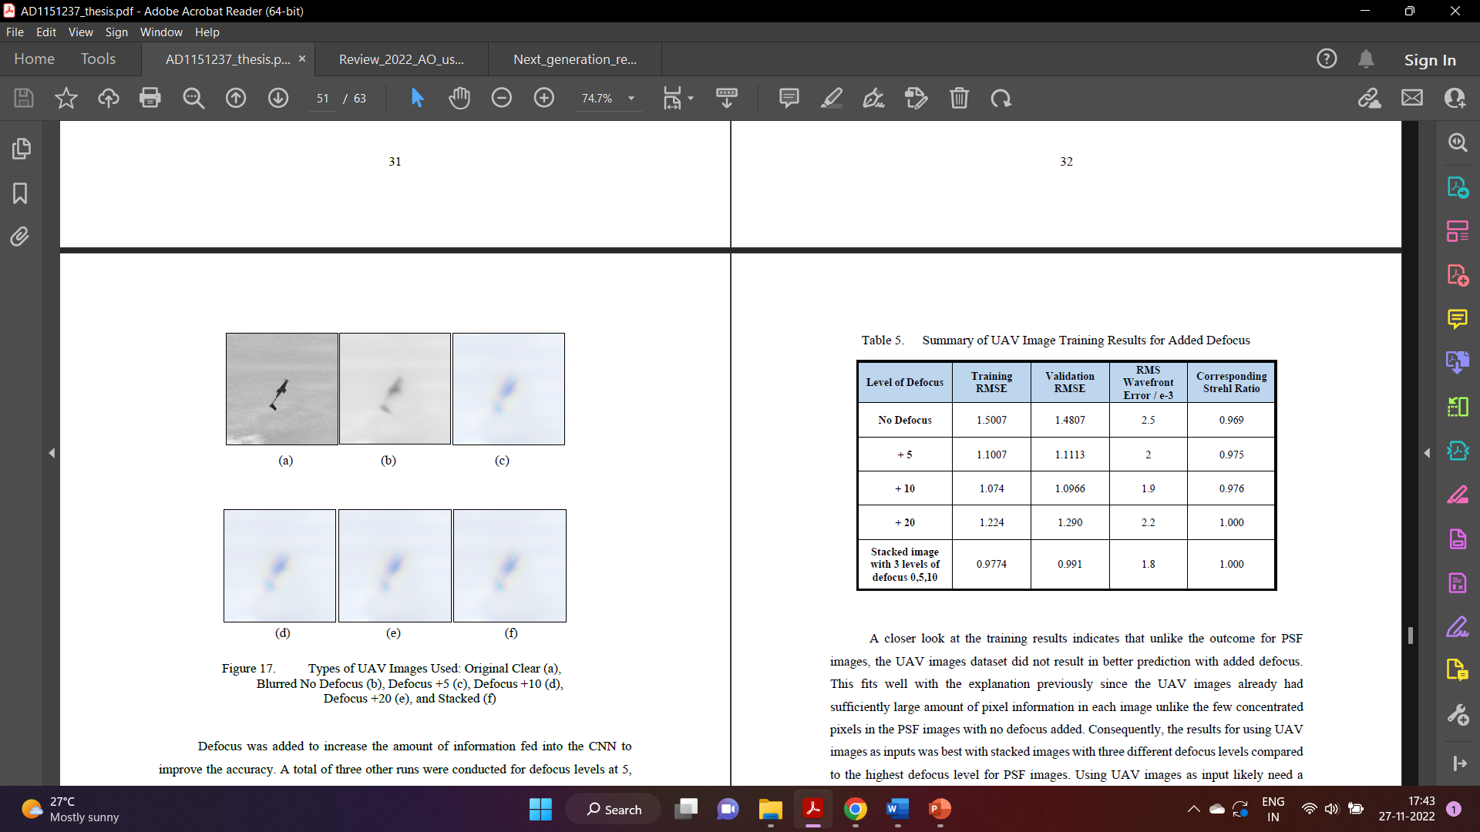

A closer look at the training results indicates that unlike the outcome for PSF images, the UAV images dataset did not result in better prediction with added defocus. This fits well with the explanation previously since the UAV images already had sufficiently large amount of pixel information in each image unlike the few concentrated pixels in the PSF images with no defocus added. Consequently, the results for using UAV images as inputs was best with stacked images with three different defocus levels compared to the highest defocus level for PSF images.

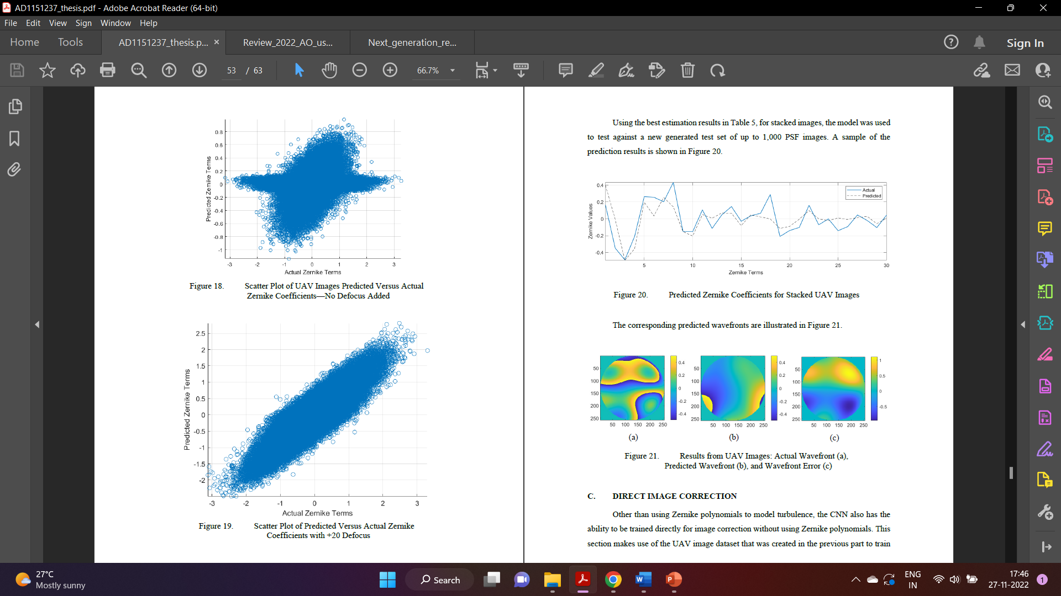 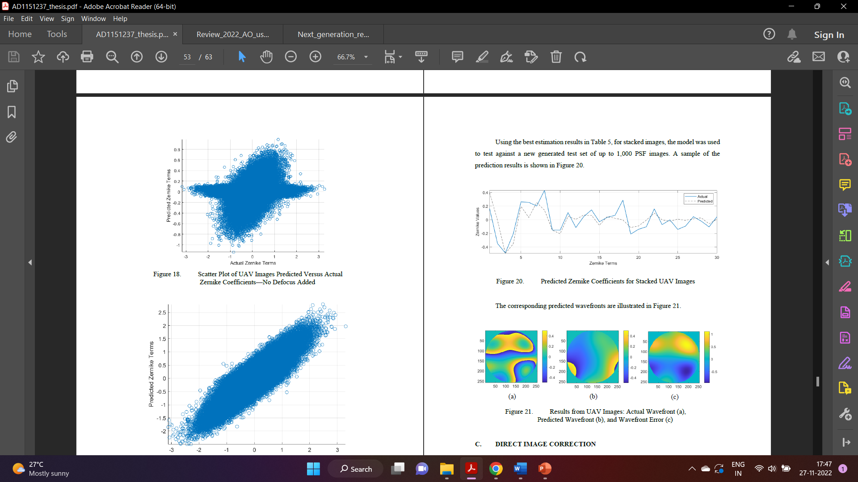

Possible Improvements:

One possible improvement to increase the accuracy of prediction is to include some form of pre-processing integral to the CNN architecture. This would help to filter out unwanted “noise” from the image. Real-world UAV images come with unwanted information like clouds and shadows which increase the complexity of the image and reduce the accuracy of prediction. Pre-processing the image would focus the information processing to the key features of the UAV and would likely result in better prediction accuracy.

The study was confined to dataset of two UAVs—the Mongoose and Reaper UAVs. While the trained networks are still usable for other UAVs, it may not give good results. Training data needs to be general enough to prevent overfitting. Hence, more training data UAV types may be required to improve the overall applicability of this model for other UAV types.

The used of direct image correction yields good results to give clearer UAV images and the spectrum of application is large. However, the applicability of this method is confined by the long processing time needed. Perhaps a customized CNN specific for this task would reduce the number of parameters in the CNN and reduce the processing time to a more palatable speed for deployment in naval ships.

2)Paper Review:

Adaptive optics (AO) is a dynamic wavefront compensation technique widely used in various applications such as ground-based telescopes, laser communication, and

biological imaging etc.

Although AO has been already successfully implemented

in many areas to improve the image resolution or

peak energy of lasers, there are still some challenging

problems. For example, how to get the wavefront of

wavefront sensor less (WFS-less) AOS or array telescopes

with high speed, how to estimate the wavefront

along the line of sight to the scientific target in multi-object

AO (MOAO) system and how to reduce the time delay

error in extreme AOSs, etc. With the development

of machine learning, especially the deep learning

techniques, some of these complex or inverse problems

can be solved. Machine learning is a concept that an algorithm

can learn and adapt to new data without human

intervention. It is usually divided into two kinds of methods,

supervised learning and unsupervised learning. Supervised

learning is provided with training data containing

not only inputs but also outputs that are also named

as labels. The most popular collection of supervised

learning algorithms is deep learning which is composed

by multiple layers of neural networks. In general, at least

three important tasks in AO require such tools including

determining the aberration from optically modulated

images in WFS, predicting future wavefront with historical

multi-source information and reconstructing the

high-resolution images from the noisy and blurred ones.

These problems are either ill-conditioned or highly nonlinear.

Typical traditional algorithms such as least square

fit (LSF), singular value decomposition (SVD), or Gauss-

Seidel et al. either have weak fitting capability or require

many iterations. On the contrary, deep learning algorithms

not only have strong fitting capabilities but also

can contain the prior information in the network’s structure

and weights. These natures can help AO solve the

above problems. Besides, the structure of AOS may be

also simplified by the powerful algorithms and computation.

**Traditional Wavefront Sensing:** Taking the solar observation

as an example, the AOS is basically composed of a deformable mirror (DM), a

WFS, a real-time controller (RTC), and a post-processing

program, as described in Fig. 1.

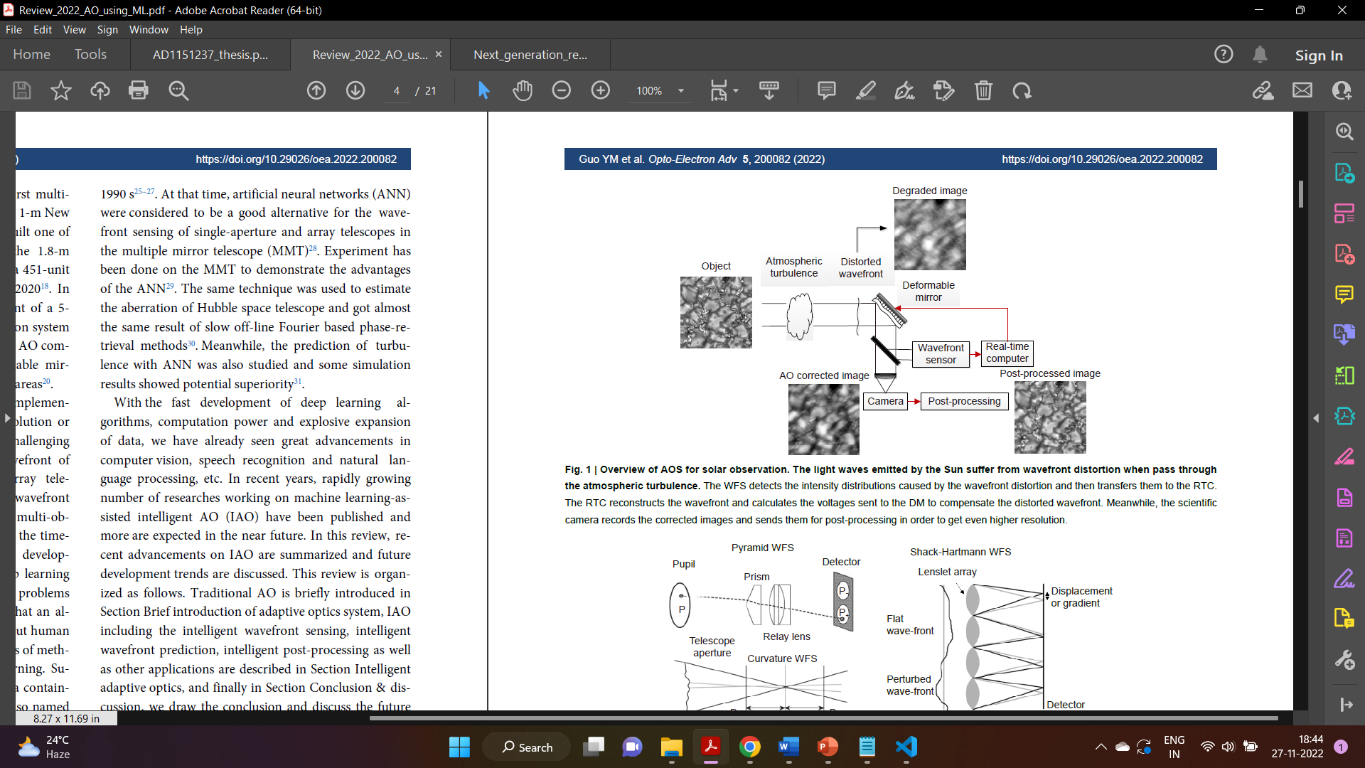

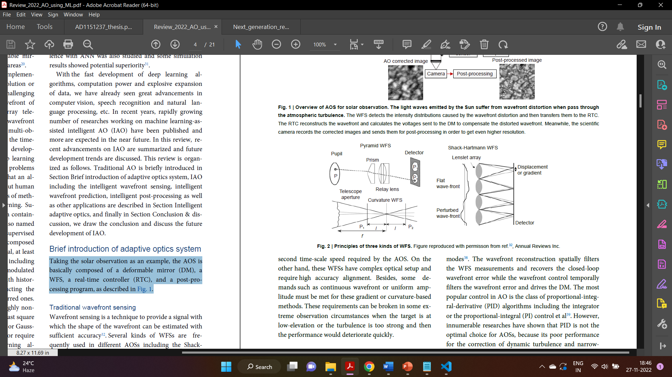

**Intelligent Wavefront Sensing:**

**S**hack-Hartmann wavefront sensor:

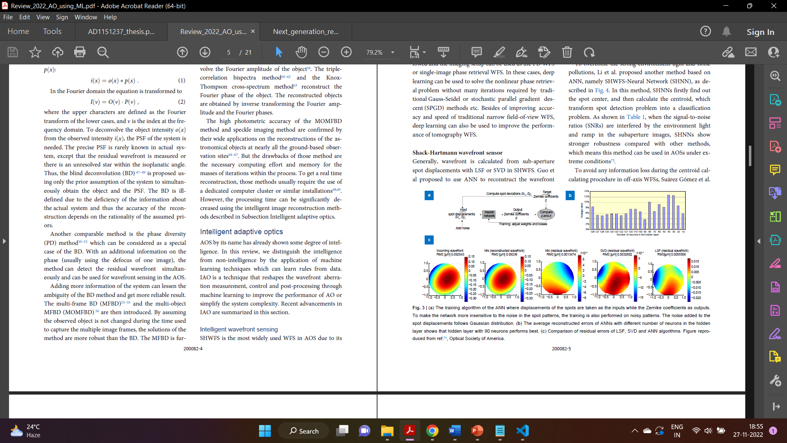

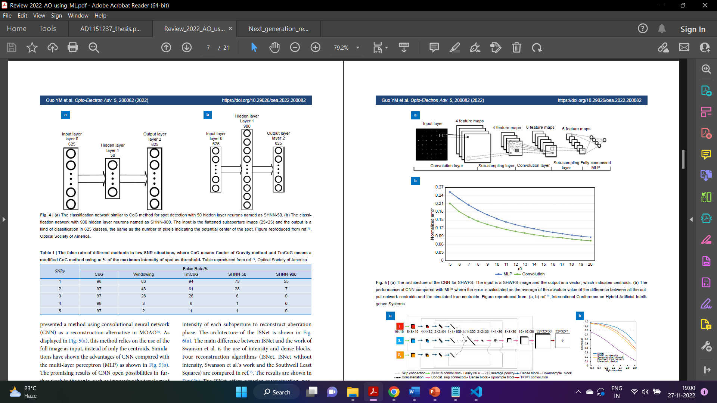

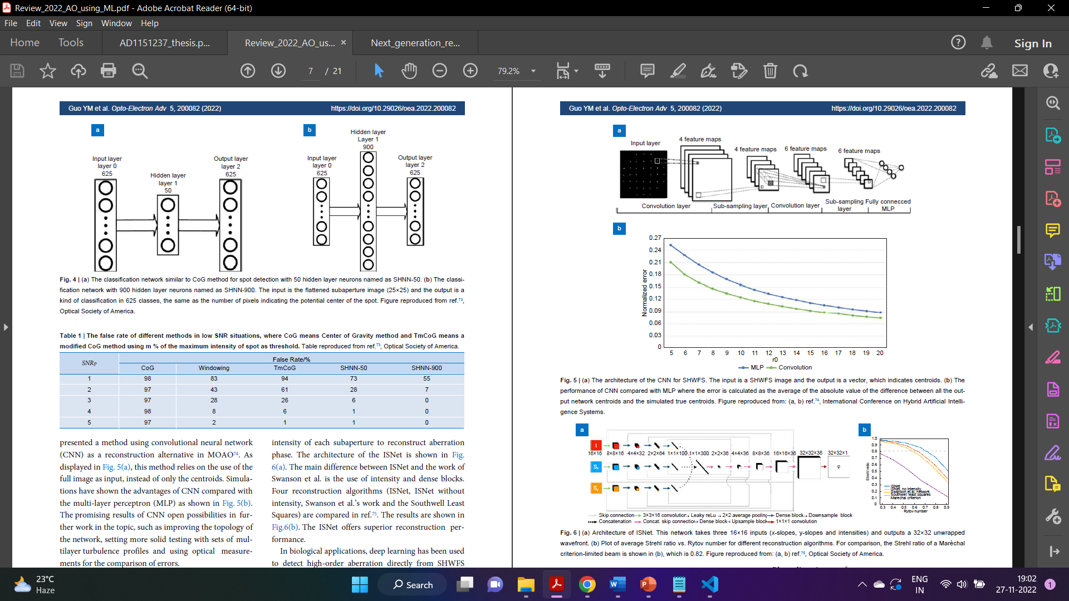

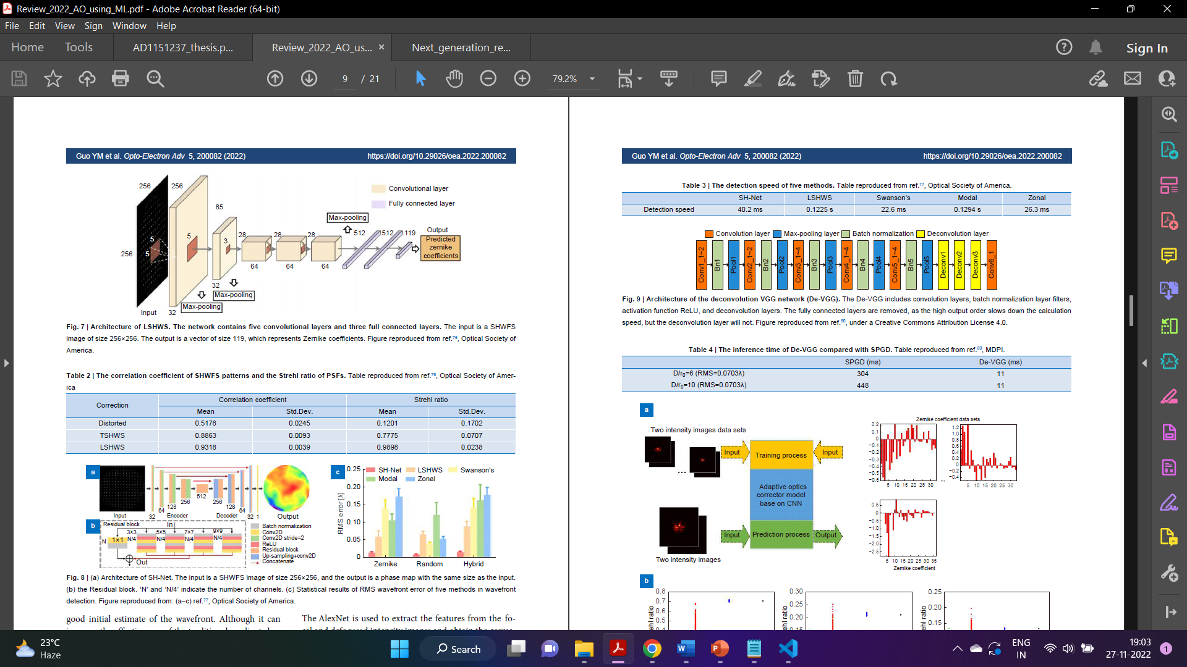

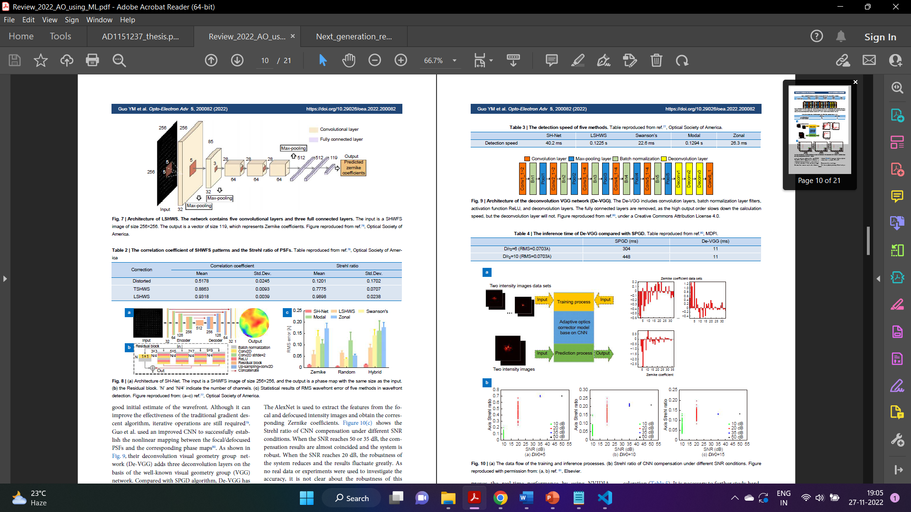

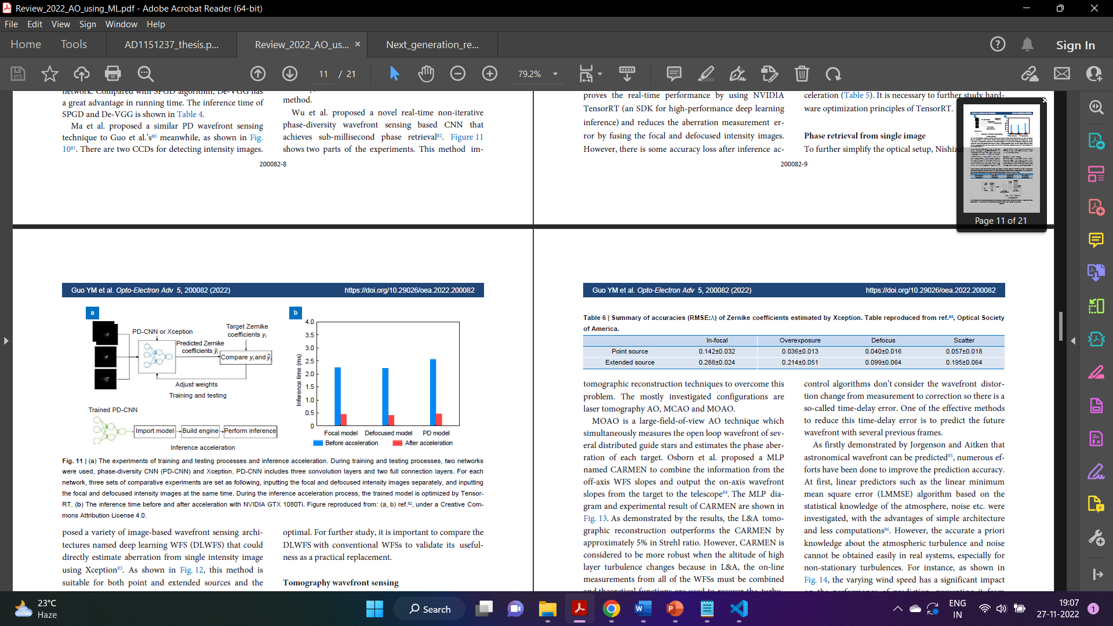

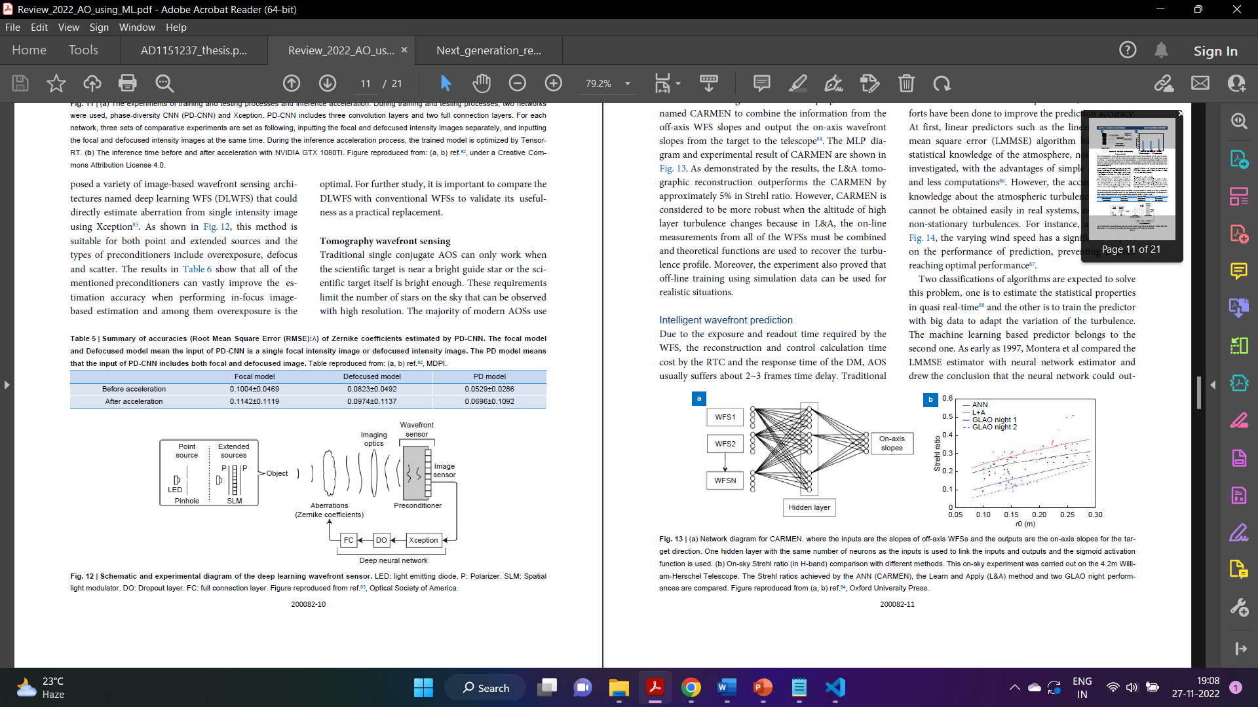

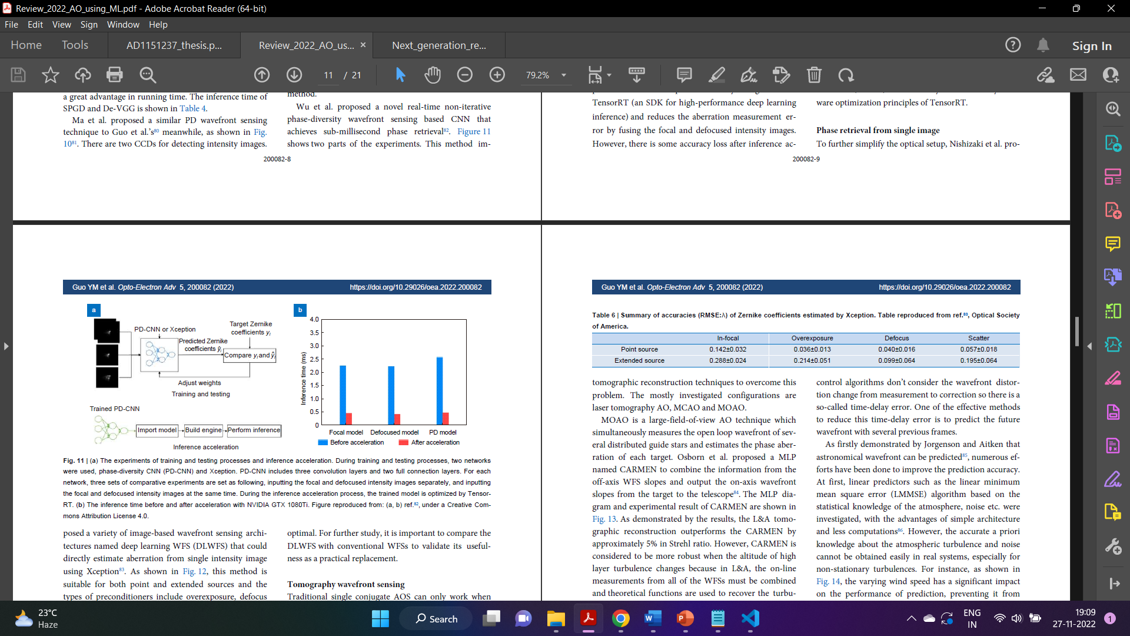

**Intelligent Wavefront Prediction:**

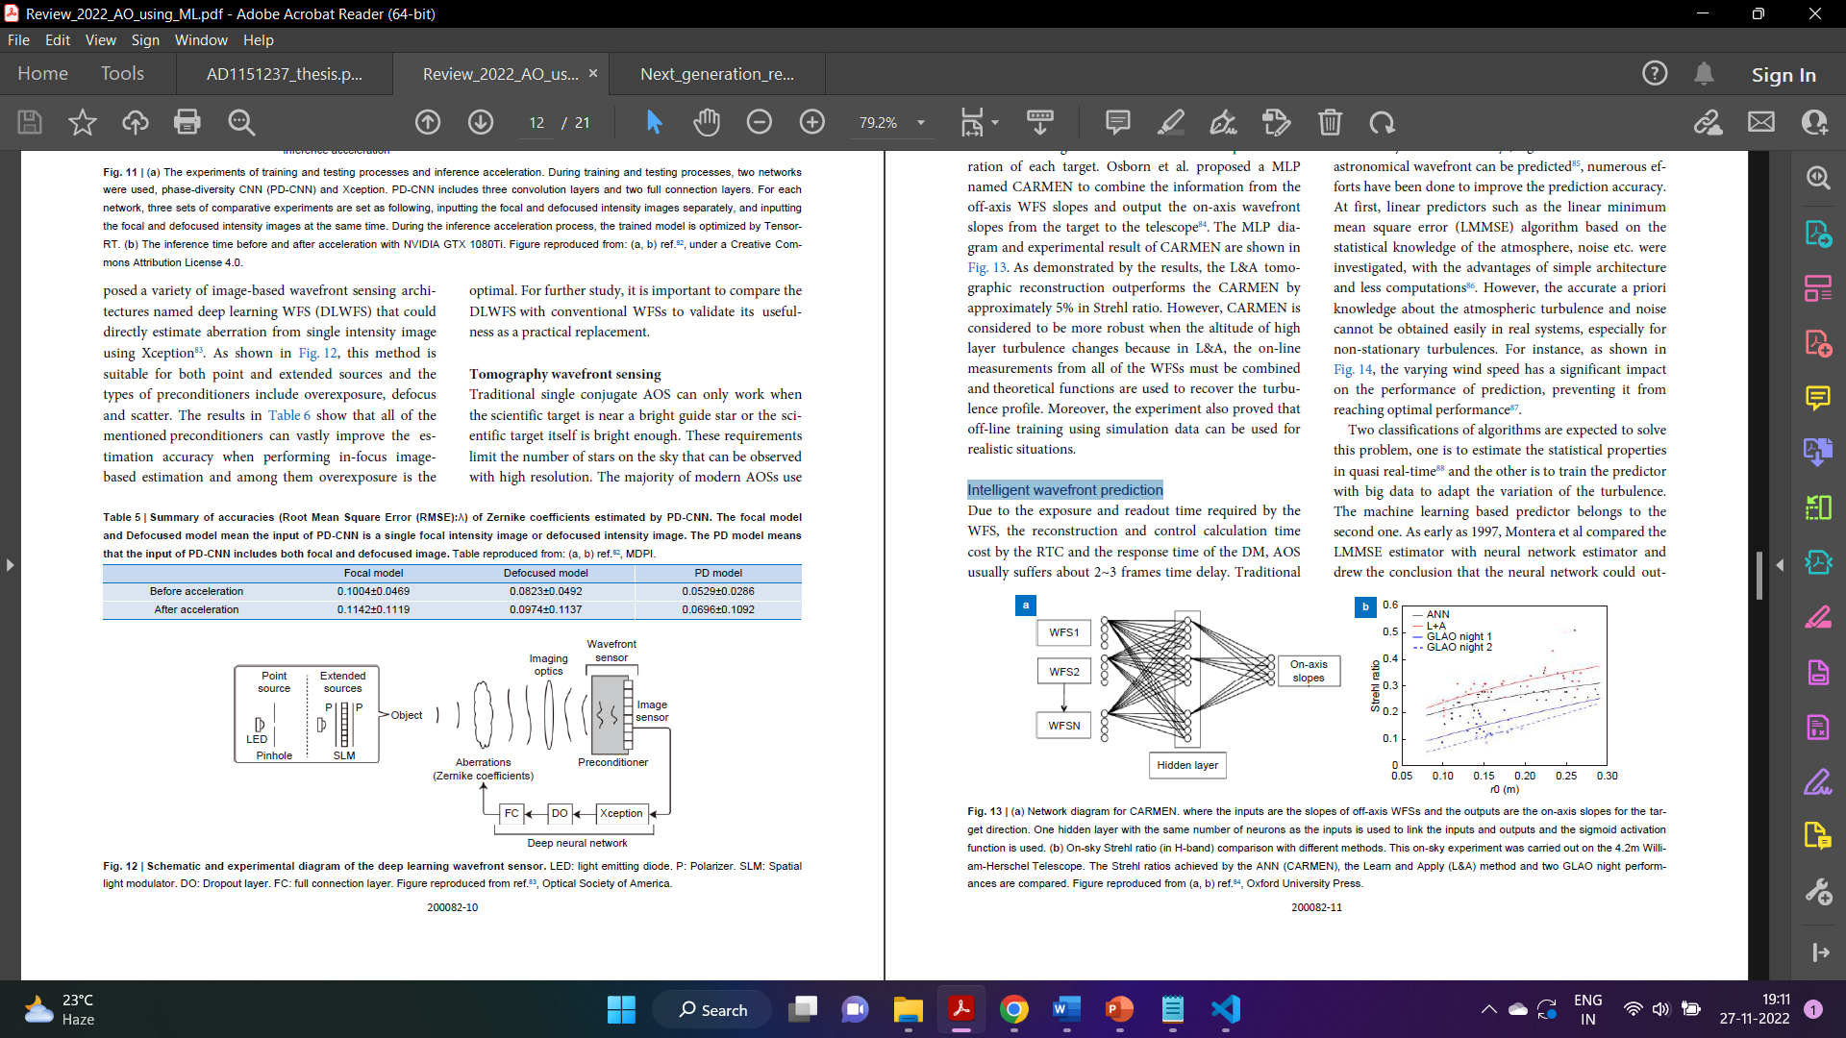

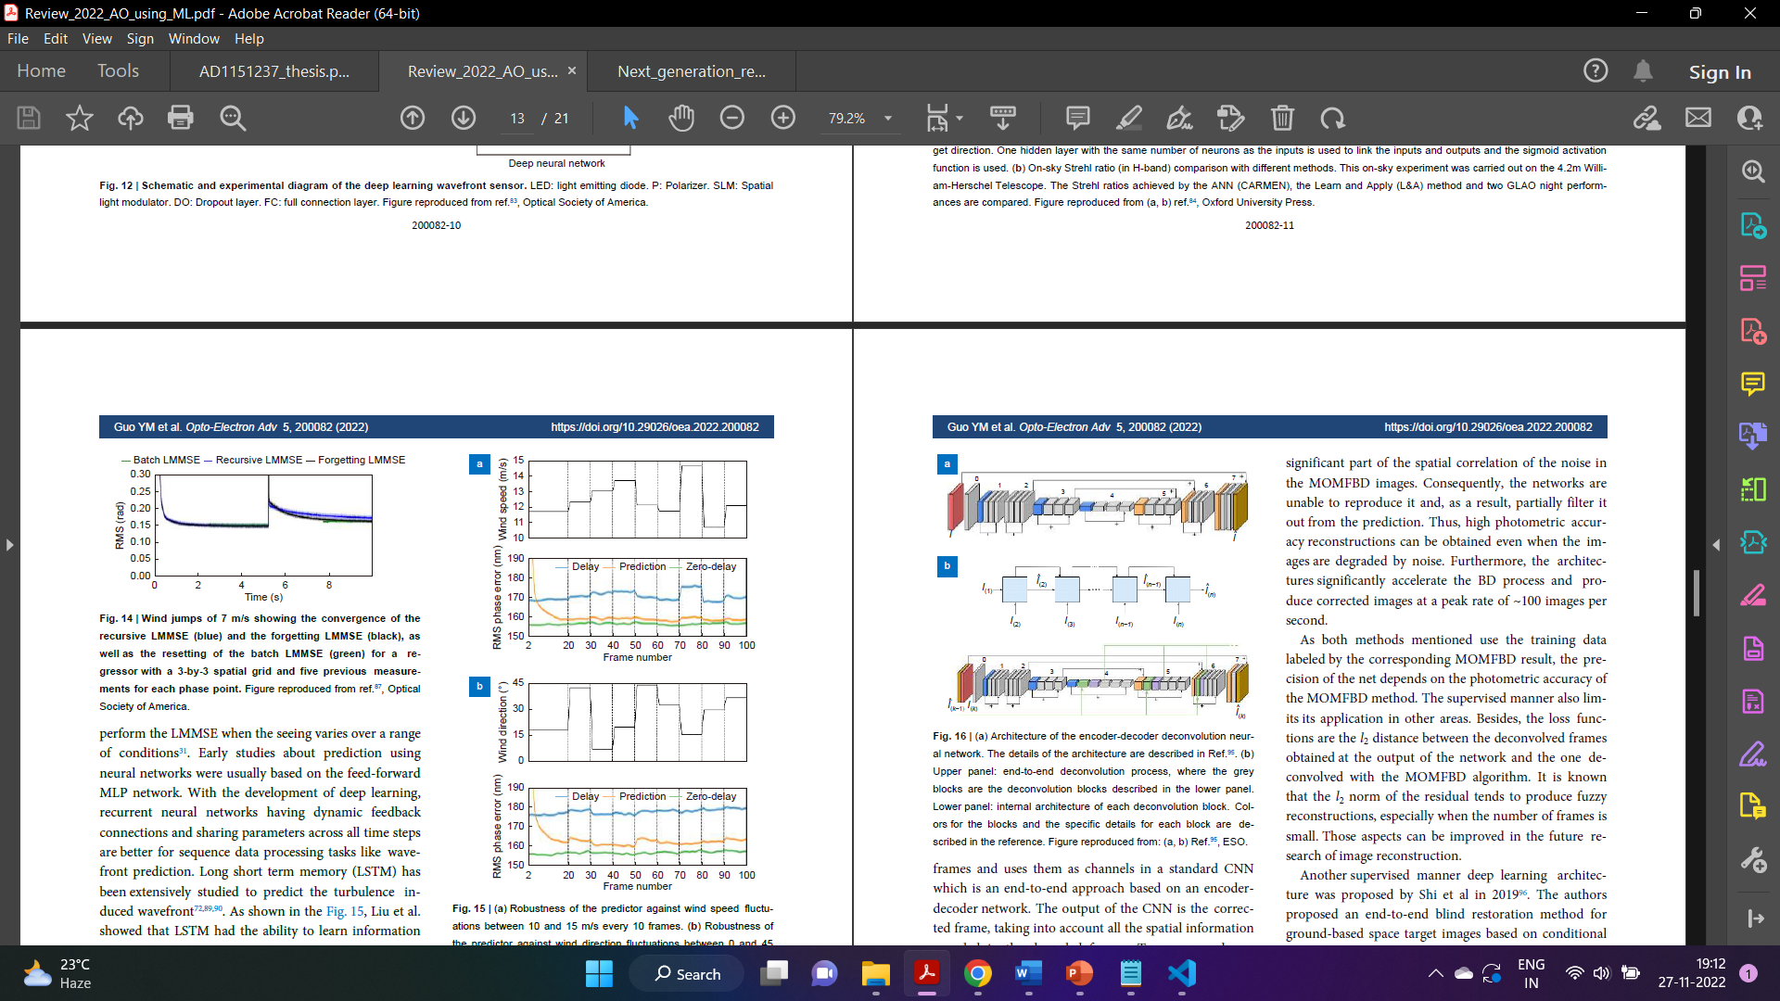 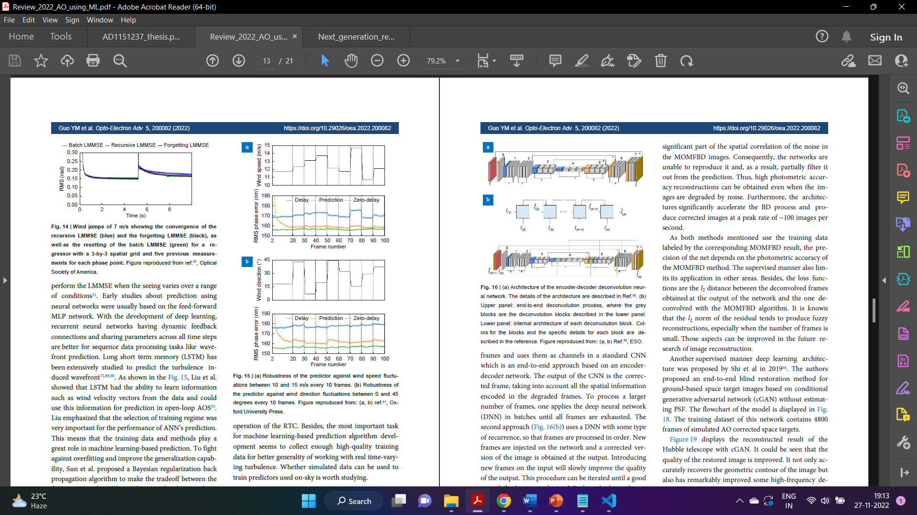

**Intelligent Post-Processing:**

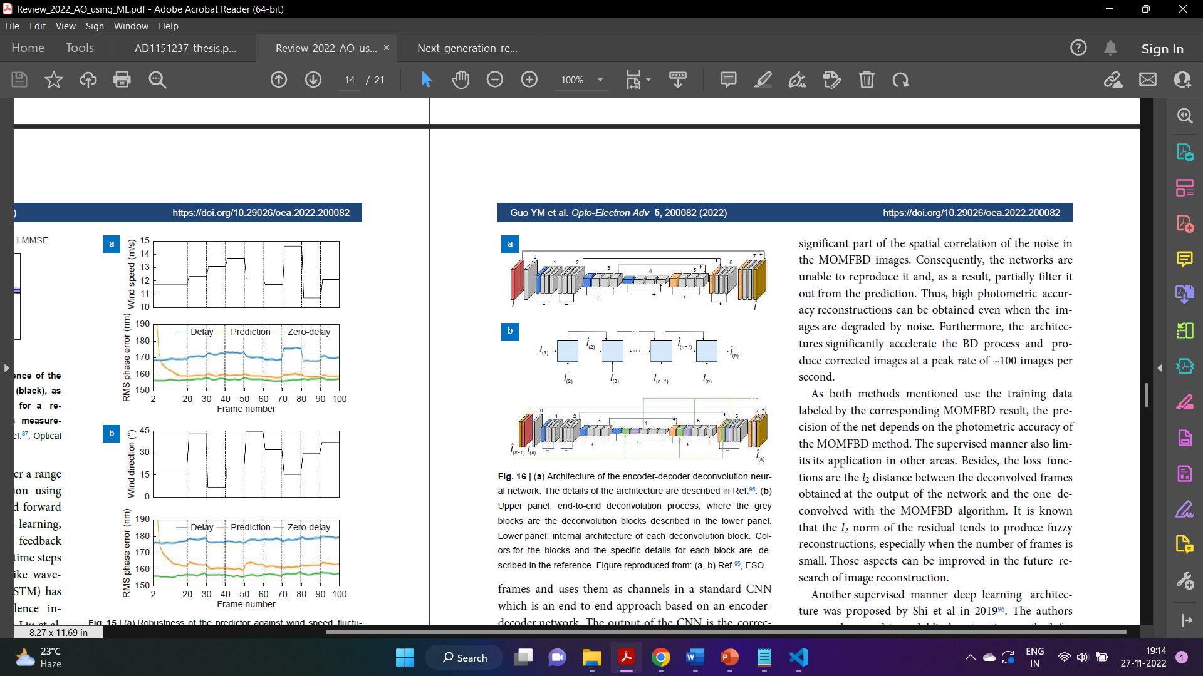

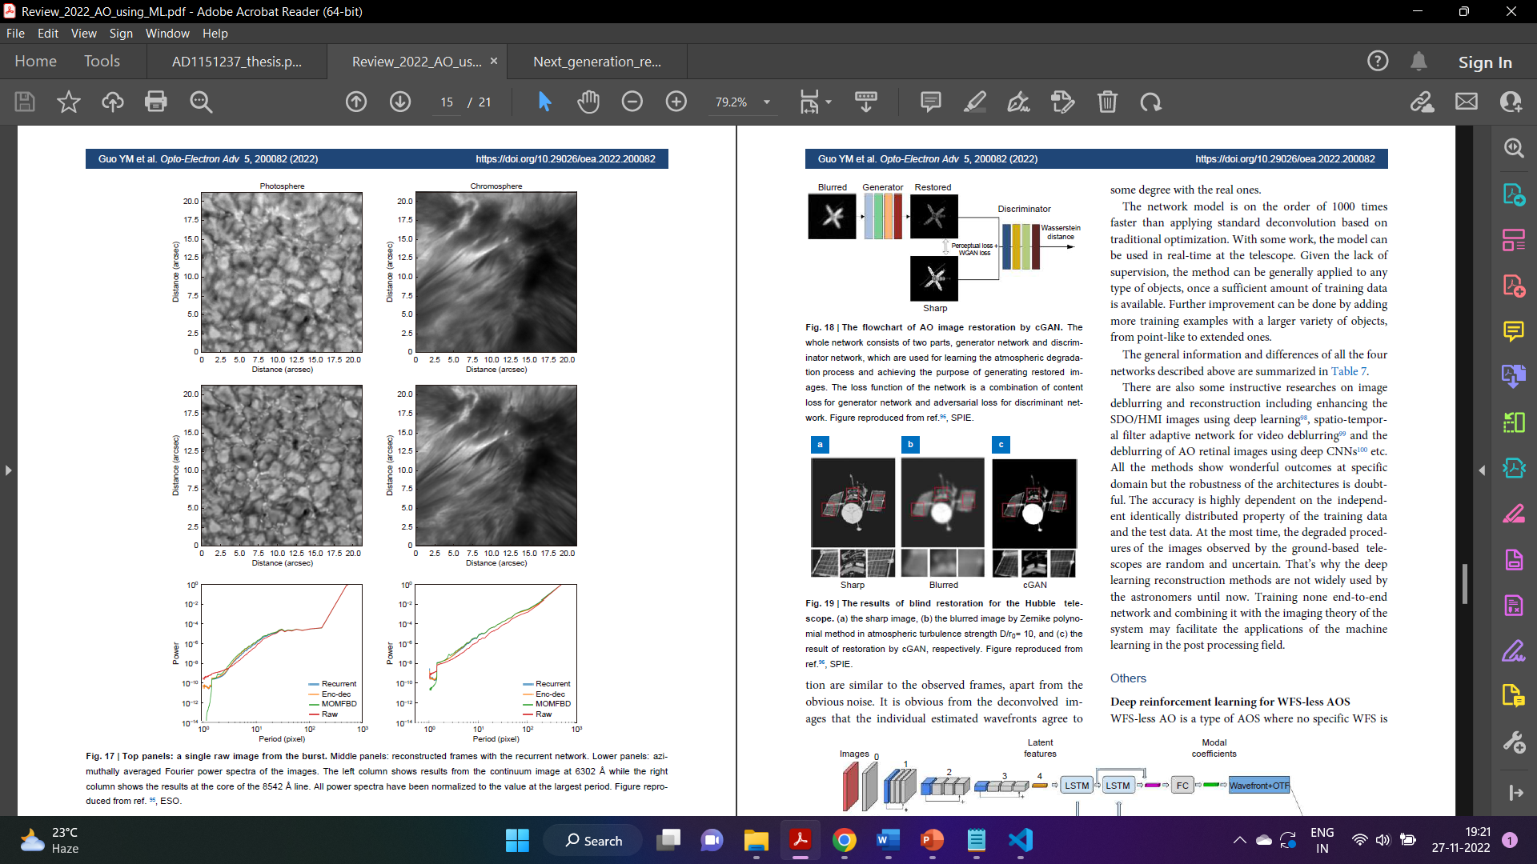

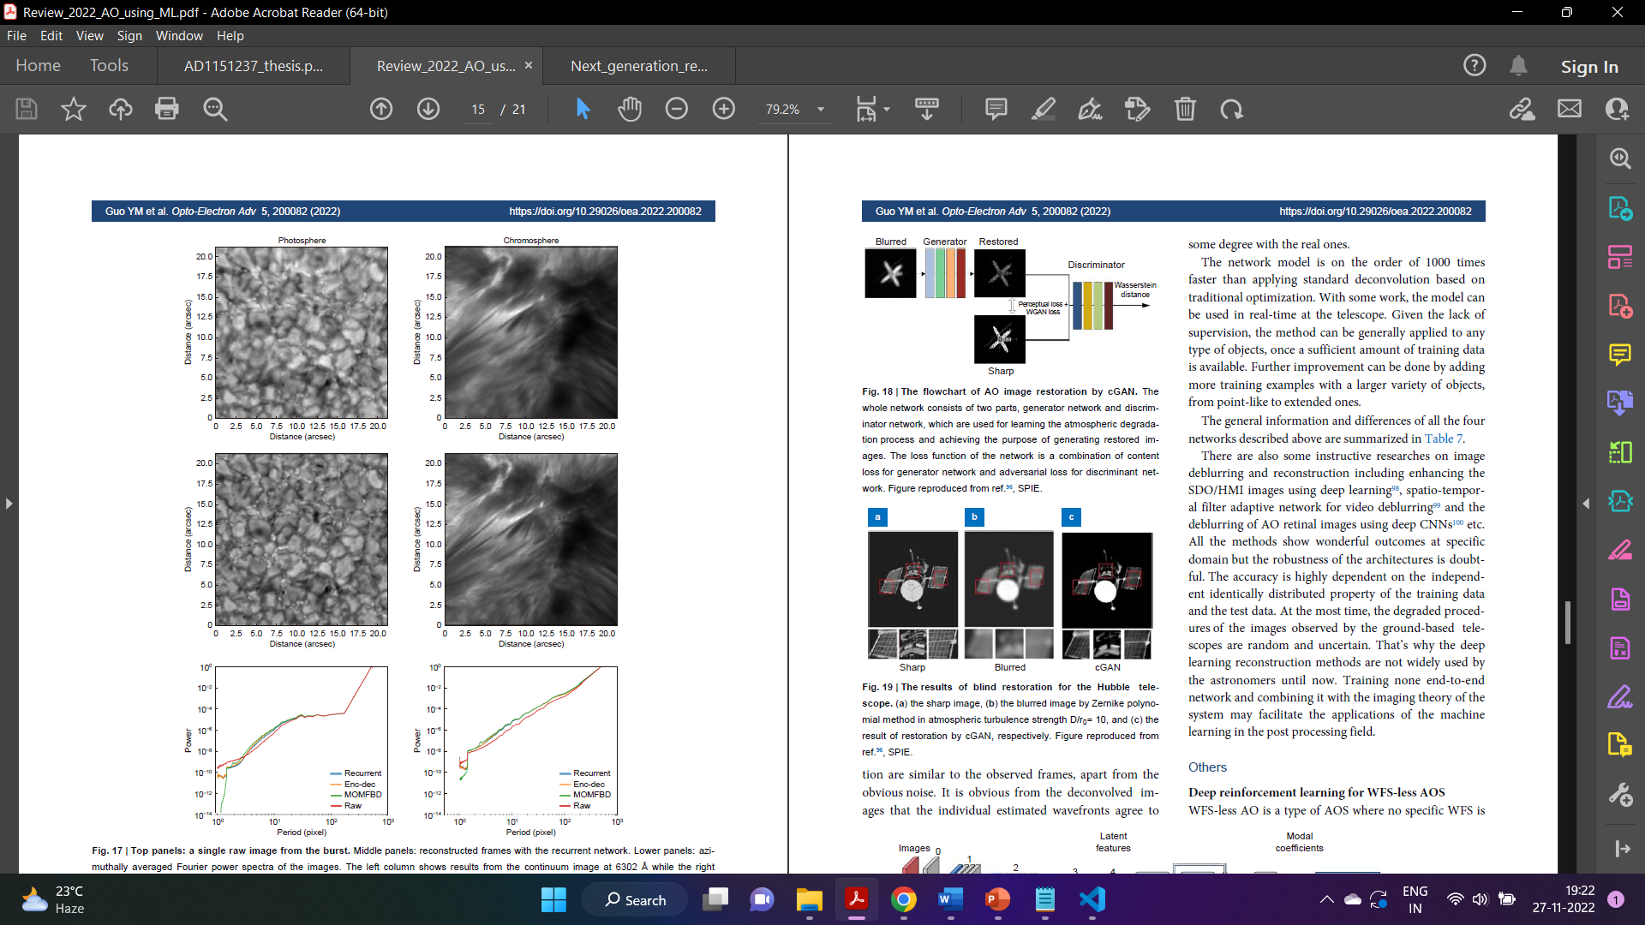

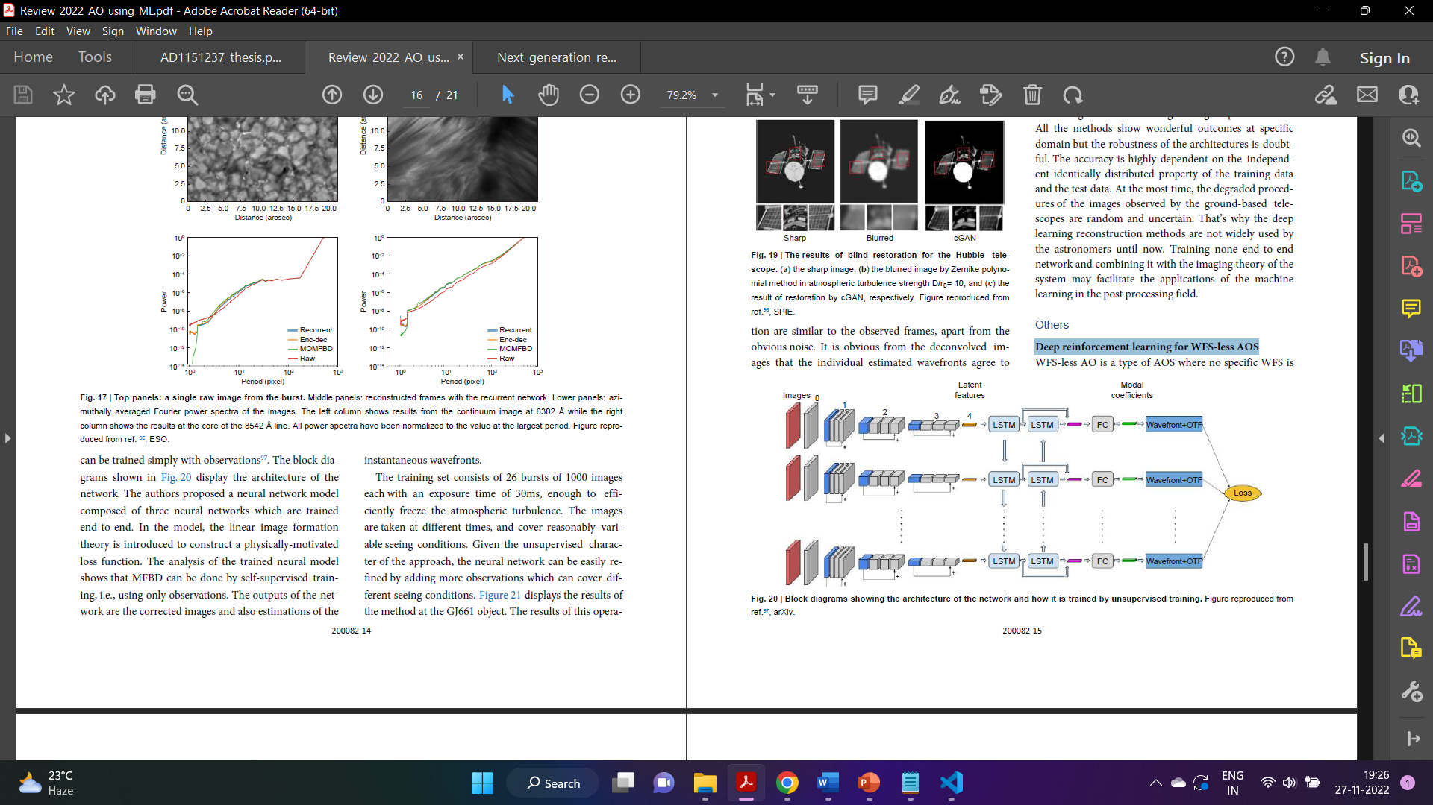

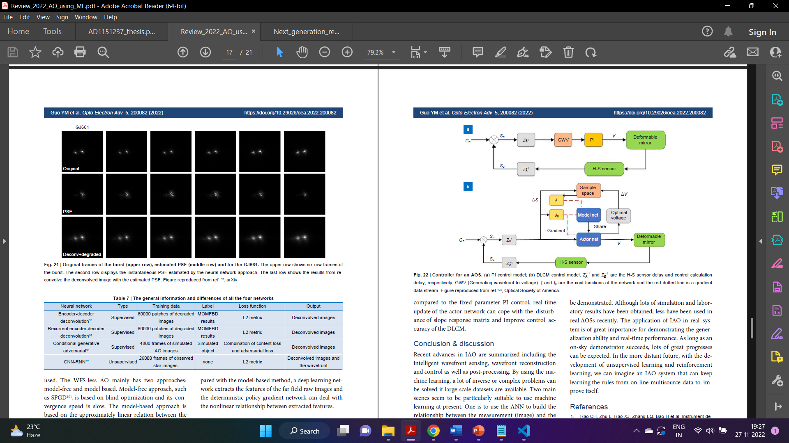

**Machine Learning for AO Modelling:**

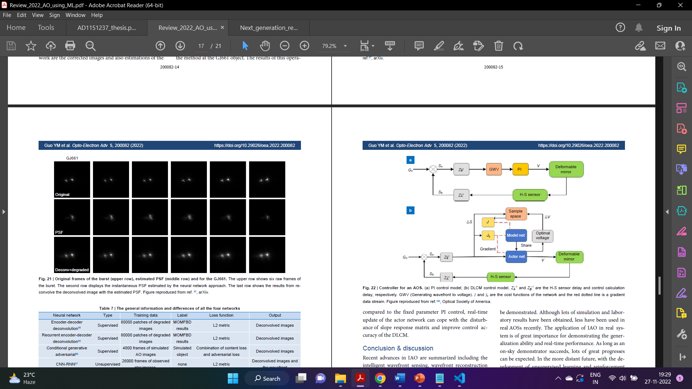

Recent advances in IAO are summarized including the

intelligent wavefront sensing, wavefront reconstruction

and control as well as post-processing. By using the machine

learning, a lot of inverse or complex problems can

be solved if large-scale datasets are available. Two main

scenes seem to be particularly suitable to use machine

learning at present. One is to use the ANN to build the

relationship between the measurement (image) and the

wavefront for wavefront reconstruction or the relationship

between blurred image and the diffraction-limited

image for post-processing. On one hand, features extracted

from data may perform better than the manually selected

linear ones. On the other hand, some iterative

methods for phase retrieval may be replaced by deep

learning for faster speed. The other is to use the ANN to

do the nonlinear wavefront prediction for better accuracy

and more importantly to adapt to the non-stationary

turbulence. Besides of the algorithms, the large-scale and high quality

data is also important which may be not easy to

get. Some data can be generated by the computer for the

training but its adaptability to the real systems needs to be demonstrated.

Although lots of simulation and laboratory

results have been obtained, less have been used in

real AOSs recently. The application of IAO in real system

is of great importance for demonstrating the generalization

ability and real-time performance. As long as an

on-sky demonstrator succeeds, lots of great progresses

can be expected. In the more distant future, with the development

of unsupervised learning and reinforcement

learning, we can imagine an IAO system that can keep

learning the rules from on-line multisource data to improve

itself.

3)Introduction to Next Generation Reservoir Computing:

Reservoir computing is a best-in-class machine learning algorithm for processing information generated by dynamical systems using observed time-series data. Importantly, it requires very small training data sets, uses linear optimization, and thus requires minimal computing resources. However, the algorithm uses randomly sampled matrices to define the underlying recurrent neural network and has a multitude of meta parameters that must be optimized. Recent results demonstrate the equivalence of reservoir computing to nonlinear vector autoregression, which requires no random matrices, fewer meta parameters, and provides interpretable results. Here, we demonstrate that nonlinear vector autoregression excels at reservoir computing benchmark tasks and requires even shorter training data sets and training time, heralding the next generation of reservoir computing.

Reservoir computing is an ML paradigm that is especially

well-suited for learning dynamical systems. Even when systems

display chaotic or complex spatiotemporal behaviors, which are

considered the hardest-of-the-hard problems, an optimized

reservoir computer (RC) can handle them with ease. Recent RC research has identified requirements for realizing a general, universal approximator of dynamical systems. A universal approximator can be realized using an RC with nonlinear activation at nodes in the recurrent network and an output layer

(known as the feature vector) that is a weighted linear sum of the

network nodes under the weak assumptions that the dynamical

system has bounded orbits.

Less appreciated is the fact that an RC with linear activation

nodes combined with a feature vector that is a weighted sum of

nonlinear functions of the reservoir node values is an equivalently

powerful universal approximator. Furthermore, such an RC

is mathematically identical to a nonlinear vector autoregression

(NVAR) machine. Here, no reservoir is required: the feature

vector of the NVAR consists of k time-delay observations of the

dynamical system to be learned and nonlinear functions of these

observations, as illustrated in Fig. 1, a surprising result given the

apparent lack of a reservoir!

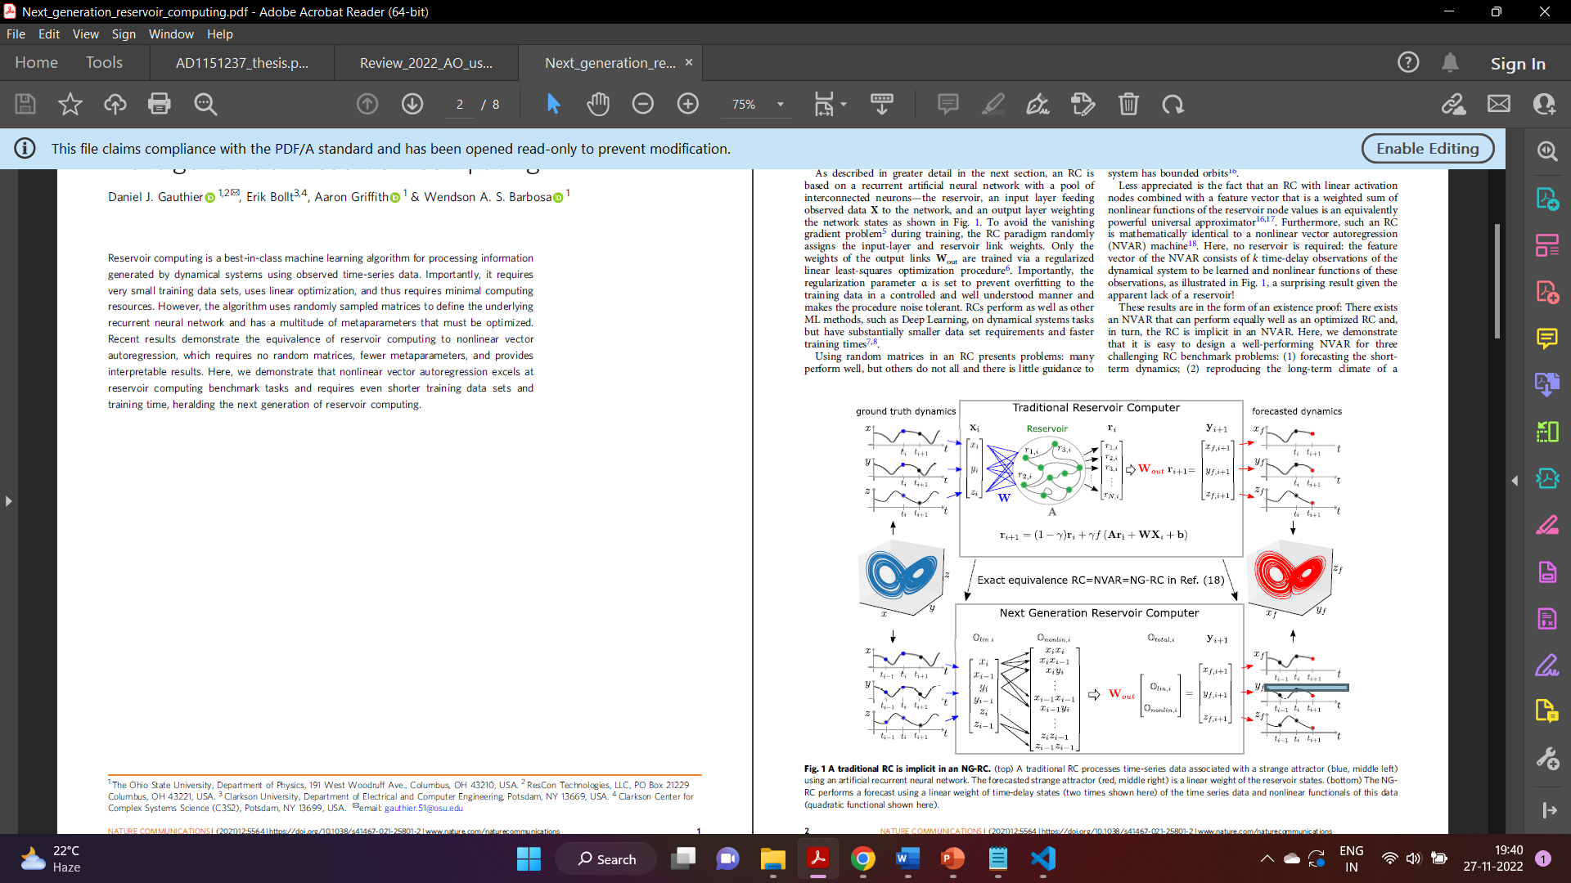

These results are in the form of an existence proof: There exists

an NVAR that can perform equally well as an optimized RC and,

in turn, the RC is implicit in an NVAR. Here, we demonstrate

that it is easy to design a well-performing NVAR for three

challenging RC benchmark problems:

(1) forecasting the short term

dynamics;

(2) reproducing the long-term climate of a chaotic system

(that is, reconstructing the attractors shown in Fig. 1);

(3) inferring the behavior of unseen data of a dynamical

system.

4)Simulations:

Plotting Zernike Pyramid,

python -m zernike.pyramid

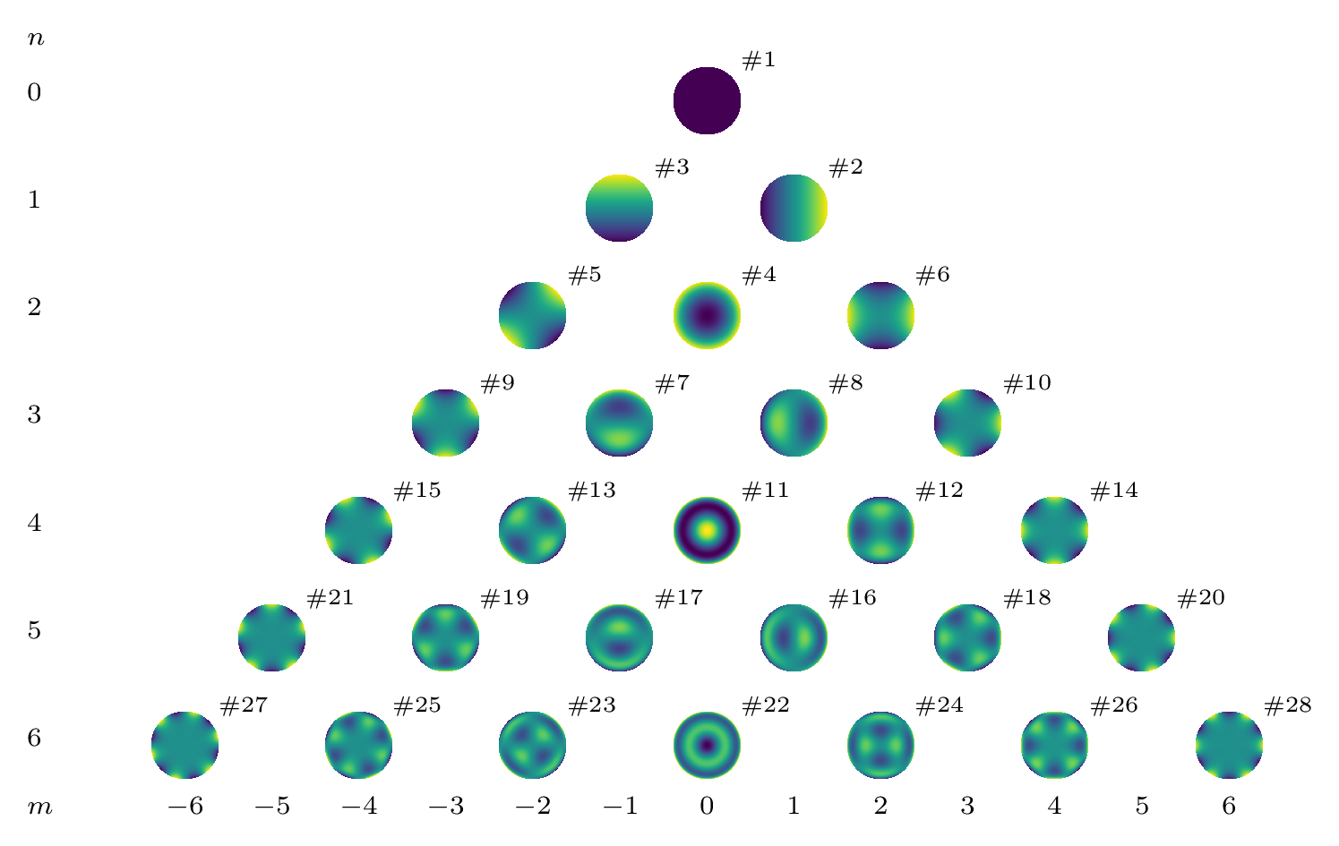

Plotting the first 9 Zernike Polynomials,

Code: <https://github.com/rahhul17/ao_project/blob/main/9_zernike.py>

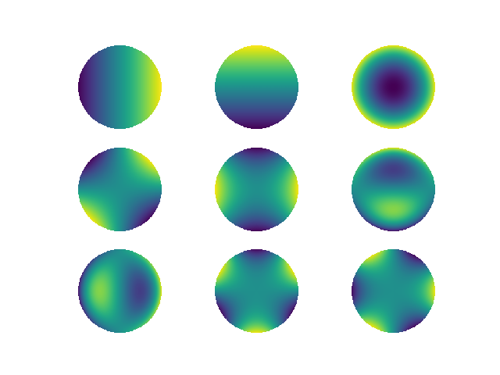

Fit Zernike Polynomials in Cartesian coordinates,

Code: <https://github.com/rahhul17/ao_project/blob/main/zernike_fit_cart.py>

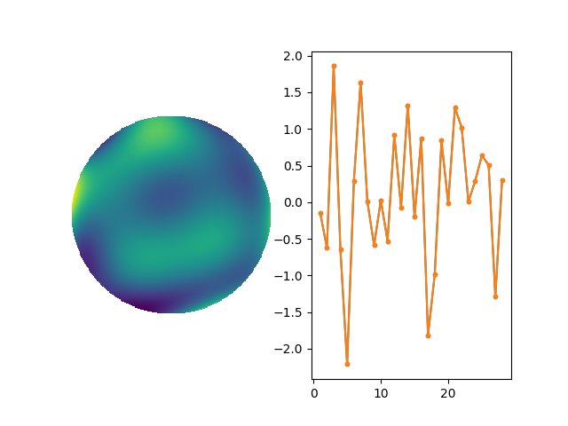

Fit Zernike in Polar Co-ordinates,

Codes: <https://github.com/rahhul17/ao_project/blob/main/zernike_polar.py>

NVAR with time delays for double-scroll forecasting, NRMSE, and fixed points.

Codes: <https://github.com/quantinfo/ng-rc-paper-code/blob/master/DoubleScrollNVAR-RK23.py>

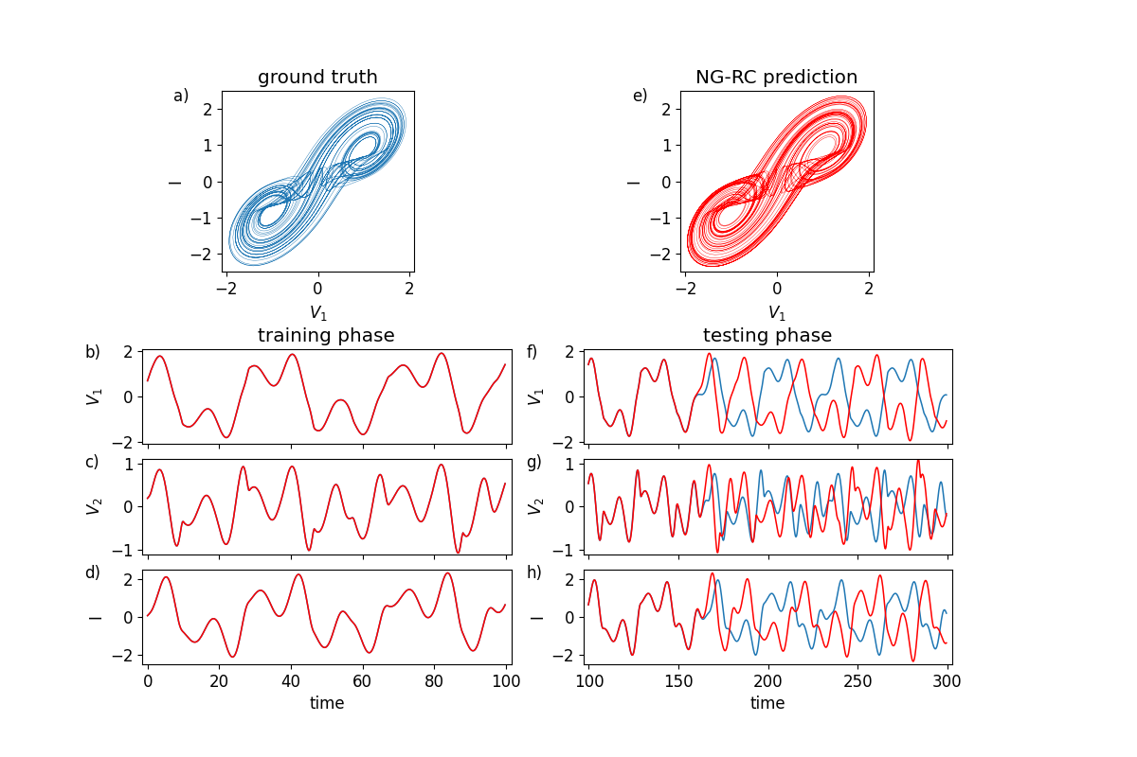

NVAR with time delays for Lorenz forecasting, NRMSE and fixed points.

Codes: <https://github.com/rahhul17/ao_project/blob/main/ng-rc-paper-code/LorenzConstLinQuadraticNVAR-NRMSE-vsTraintime.py>

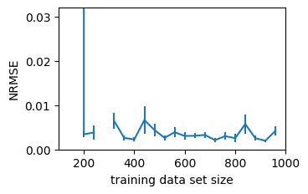

NVAR with time delays for Lorenz forecasting

Codes: <https://github.com/rahhul17/ao_project/blob/main/ng-rc-paper-code/LorenzConstLinQuadraticNVAR-Noise.py>

<https://github.com/rahhul17/ao_project/blob/main/ng-rc-paper-code/LorenzConstLinQuadraticNVARtimedelay-RK23.py>

<https://github.com/rahhul17/ao_project/blob/main/ng-rc-paper-code/LorenzConstLinQuadraticNVARtimedelayNRMSE-RK23.py>

<https://github.com/rahhul17/ao_project/blob/main/ng-rc-paper-code/LorenzConstLinQuadraticNVARtimedelayReturnMap-RK23.py>

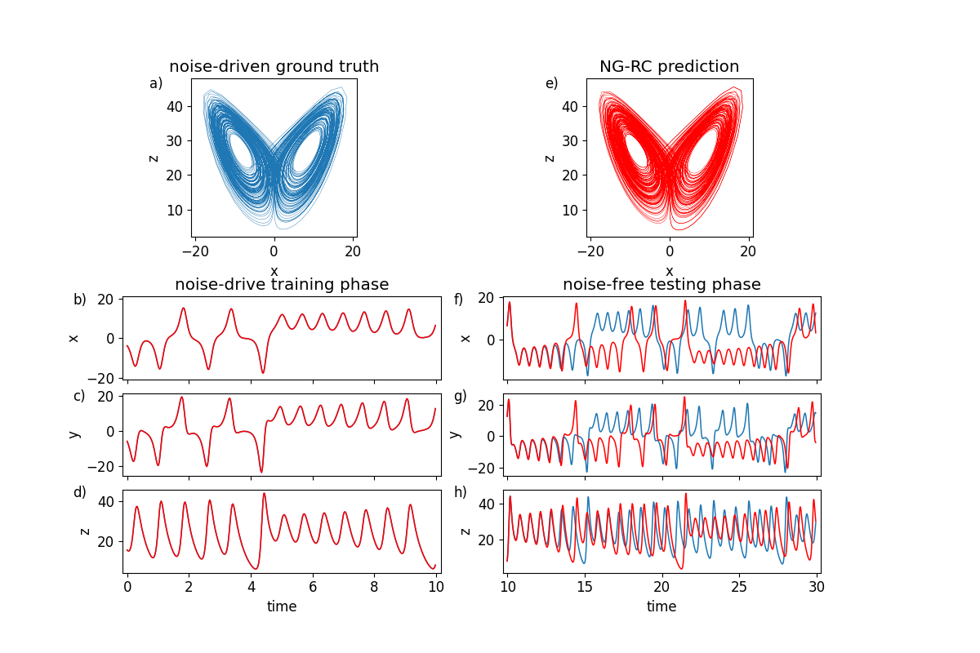

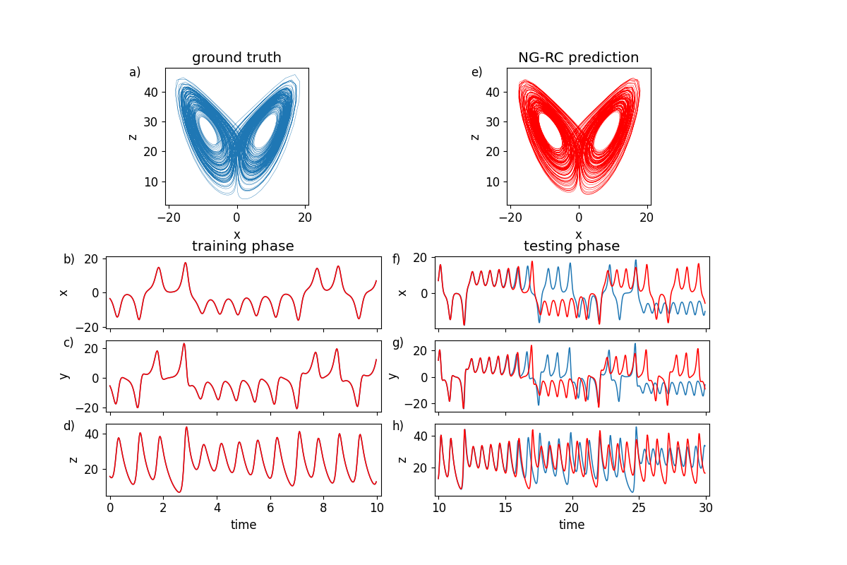

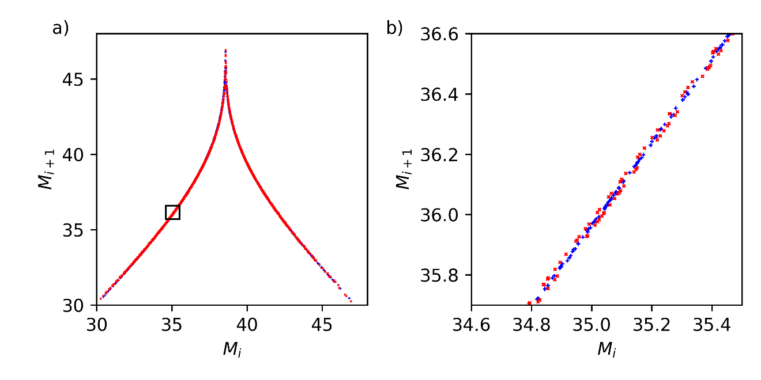

NVAR with time delays for Lorenz prediction. Measure x, y, predict z

Code: <https://github.com/rahhul17/ao_project/blob/main/ng-rc-paper-code/LorenzPredictZQuadraticNVARtimedelay-RK23.py>

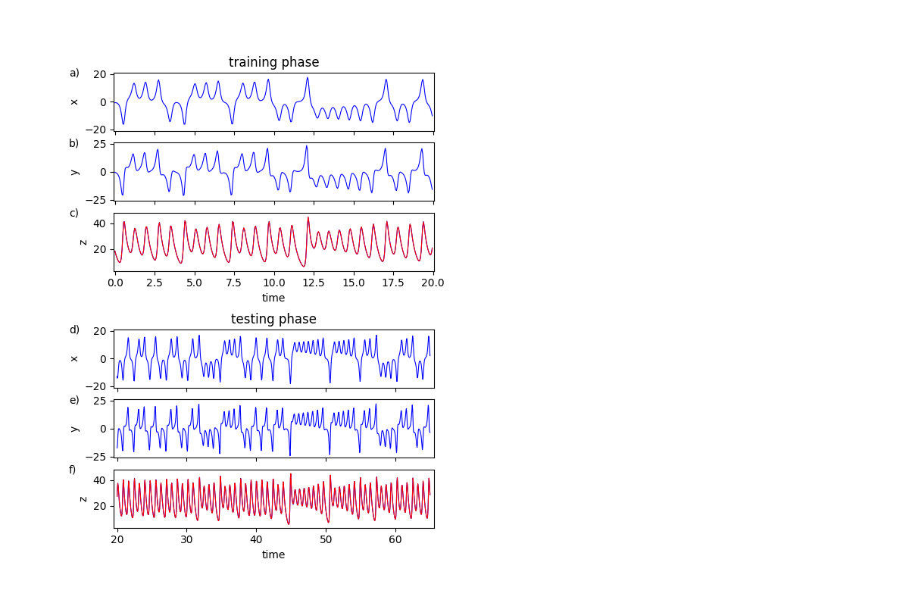

NVAR with time delays for Lorenz prediction, NRMSE.

Code :<https://github.com/rahhul17/ao_project/blob/main/ng-rc-paper-code/LorenzPredictZQuadraticNVARtimedelayNRMSE-RK23.py>

NVAR with time delays for Lorenz prediction, W_out plots.

Codes: <https://github.com/rahhul17/ao_project/blob/main/ng-rc-paper-code/LorenzPredictZQuadraticNVARtimedelayWout-RK23.py>

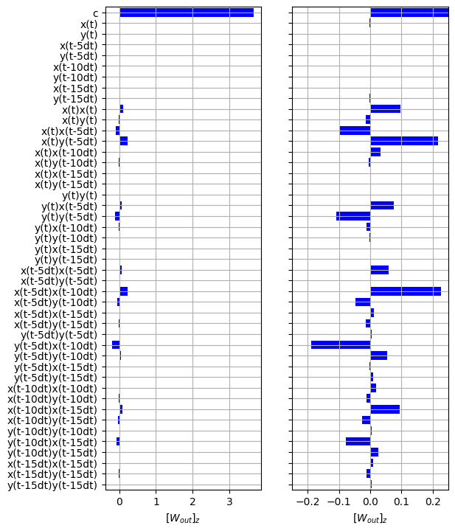

NVAR with time delays for Lorenz forecasting, W_out plots,

Codes: <https://github.com/rahhul17/ao_project/blob/main/ng-rc-paper-code/LorenzQuadraticNVARtimedelayWout-RK23.py>

